LEARNING MANAGEMENT SYSTEM (LMS)
SCREENSHOT DOCUMENTATION
Login Credentials
Admin Login:
Link : http://162.241.124.230/~themworess/demo/thesar_lms/
Email : admin@gmail.com
Password : Admin@123

Instructor Login:
Link : http://162.241.124.230/~themworess/demo/thesar_lms/
Email : suriyaselva.inet@gmail.com
Password : 123456

Student Login:
Link : http://162.241.124.230/~themworess/demo/thesar_lms/
Email : thenmozhi.inetsolutions@gmail.com
Password : 123456

ADMIN PAGE:
- Dashboard
1.1 Admin can view all required numbers that need viewing more often are displayed on the dashboard. Revenue details are shown in column chart.
1.2 Such as income from the total number of courses, lessons, enrollment, and the most recent payout withdrawal request, etc.
Status: Completed
URL: http://162.241.124.230/~themworess/demo/thesar_lms/admin/dashboard
Screenshot:
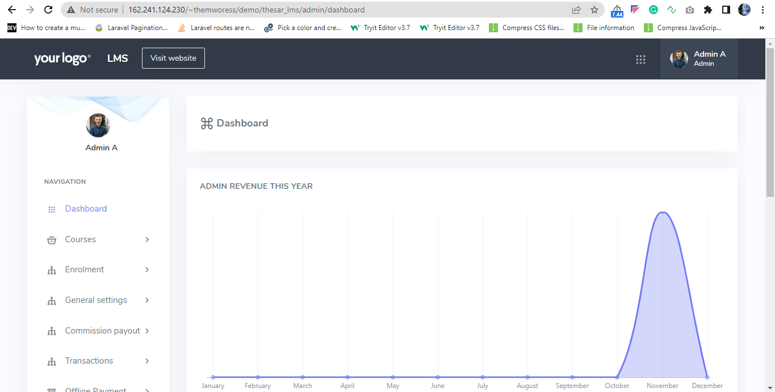

2. Manage Courses
2.1 The administrator manages all courses.
2.2 Approves pending instructor courses and sells own courses direct.
2.3 Here admin can filter the course list based on selection. Admin can edit the course details, view playing course page, and view the section and lesson page details.
2.4 Before creating a course, the administrator must first create a section. Go to the course menu on the Admin left to complete a new course. It is possible to add a new course.
2.5 Here admin can create new course categories and subcategory details. Giving course description, select category, level of course like (beginner, Advanced, Intermediate).
2.6 Learning management details page access to the coupon and discounts. Admin can add different coupon details. These coupons can help you save money on your entire course when you check it.
Status: Completed
URL: http://162.241.124.230/~themworess/demo/thesar_lms/admin/courses
Screenshot:
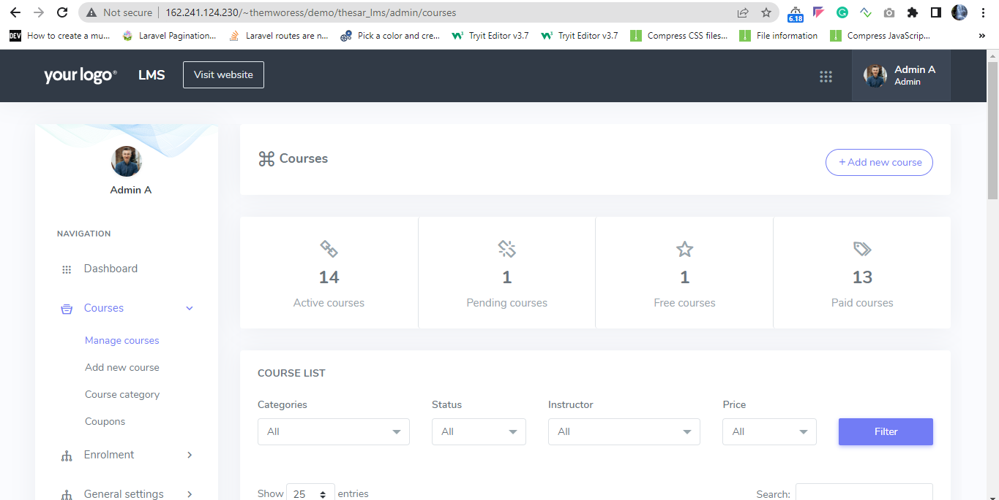

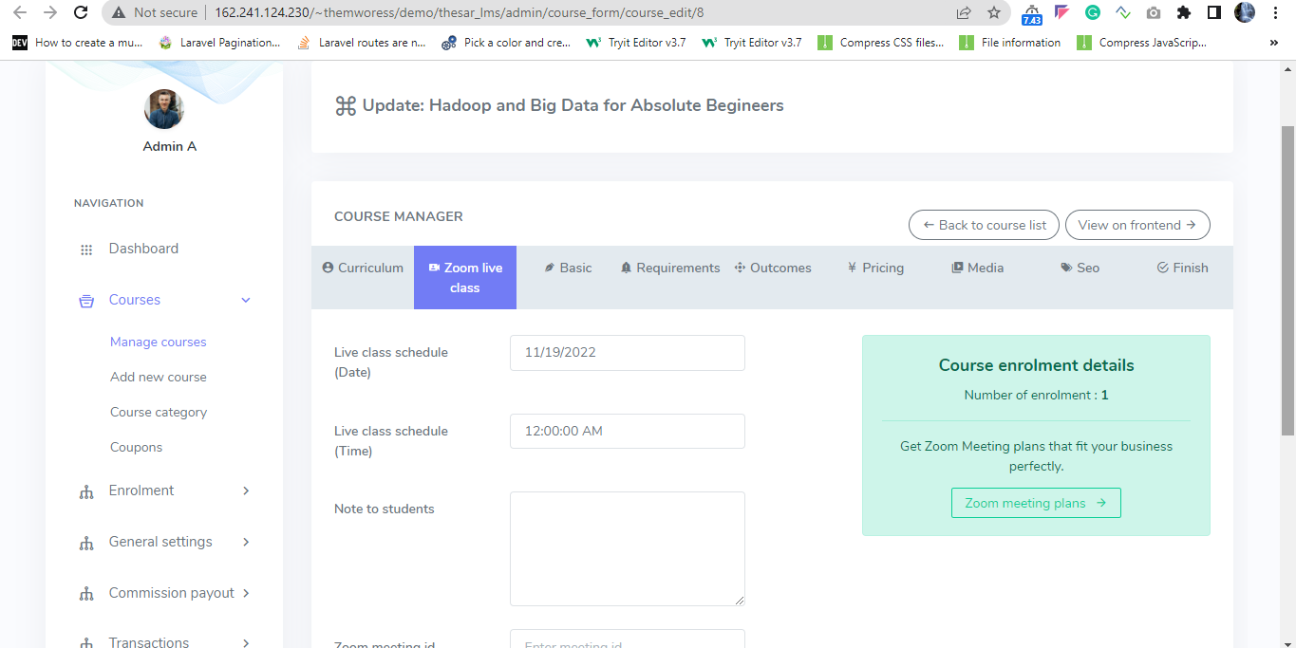
Admin or Course creator can edit zoom live class settings.
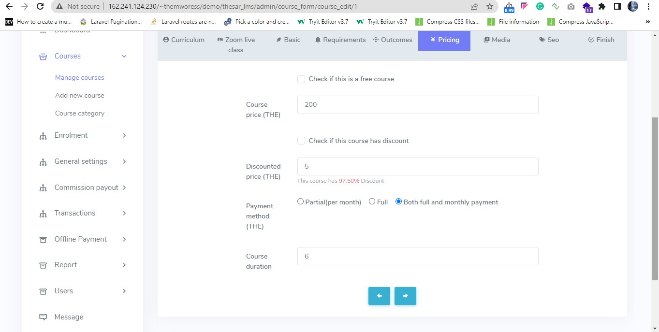

In this section admin or course creator can configure payment method (partial, full, both full and partial payment) and course duration.

3. Enrolment
3.1 Admin will see the list of all the enrolled students on the Enroll history page.
3.2 Admin can find this from the admin navigation menu to Enroll History.
3.3 Admin can enroll a student manually. From Enroll A Student option, and can filter the enroll History.
Status: Completed
URL: http://162.241.124.230/~themworess/demo/thesar_lms/admin/enrol_history
Screenshot:
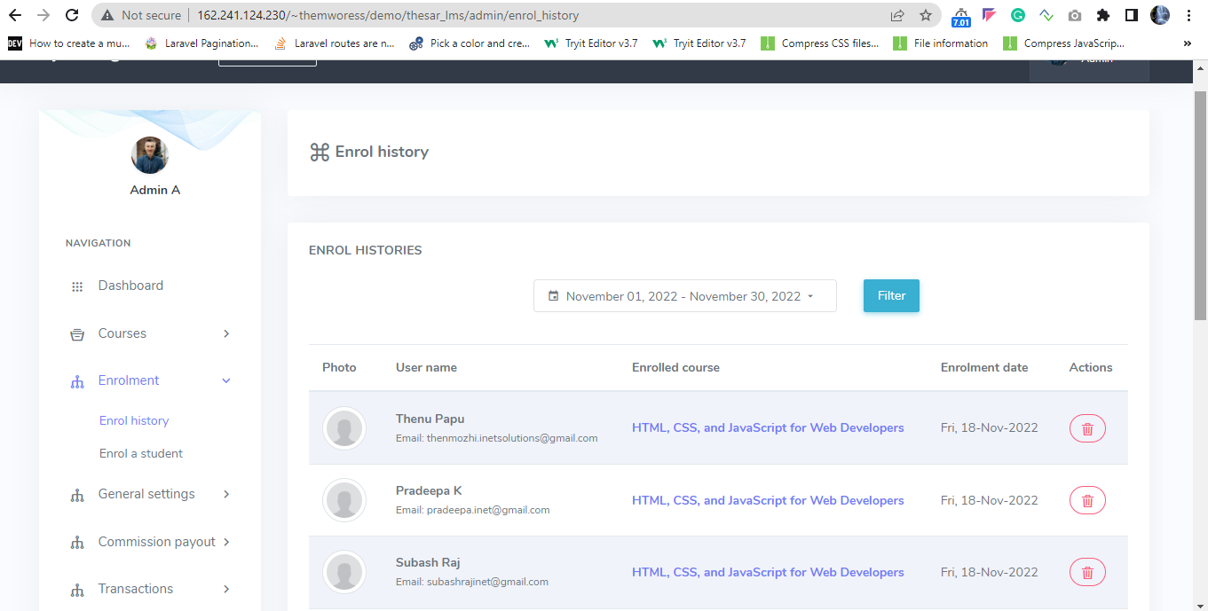

4 Report
4.1 Admin revenue option will show all of them. After every successful course purchasing, Admin will get the entire amount as revenue if he creates the Course.
4.2 And if he is not the creator of that Course, he will get a predefined amount from that. Admin revenue, instructor revenue, total amount of instructor revenue
4.3 An instructor publishes a course. After a successful purchase, Admin will pay him a payment, which will be displayed here with all payment information and payment status.
Status: Completed
URL: http://162.241.124.230/~themworess/demo/thesar_lms/admin/admin_revenue
Screenshot:
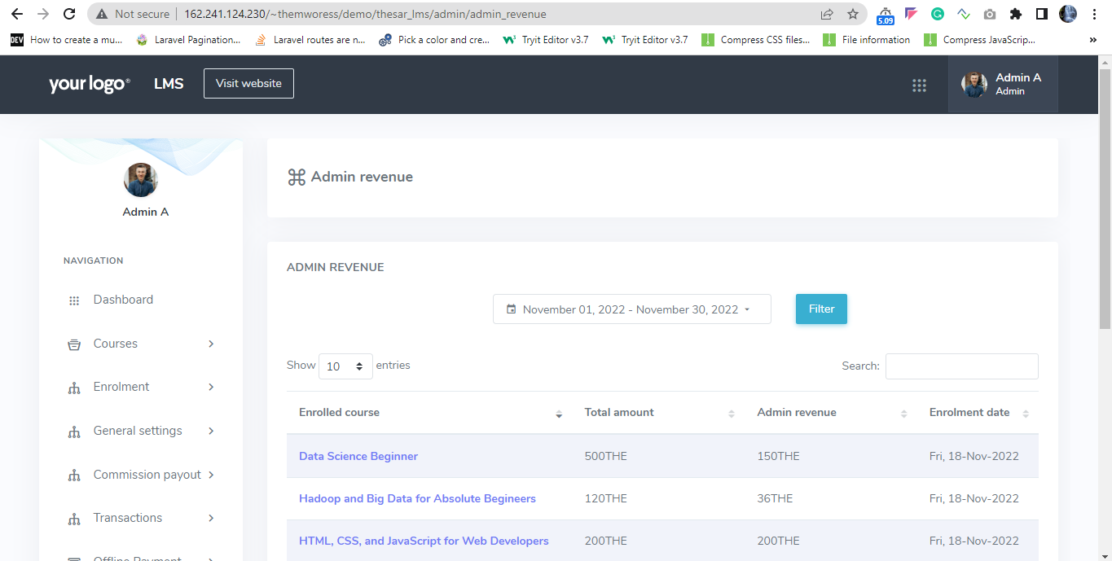
5 User management
Admin
5.1 A main admin can manage other admin in the academy.
5.2 Main admin can provide permissions to them like if you permit an admin to access the courses only, he can only access the Course feature.
5.3 A main admin can create multiple list of other admin. They are called as sub-admin.
Status: Completed
URL: http://162.241.124.230/~themworess/demo/thesar_lms/admin/admins
Screenshot:
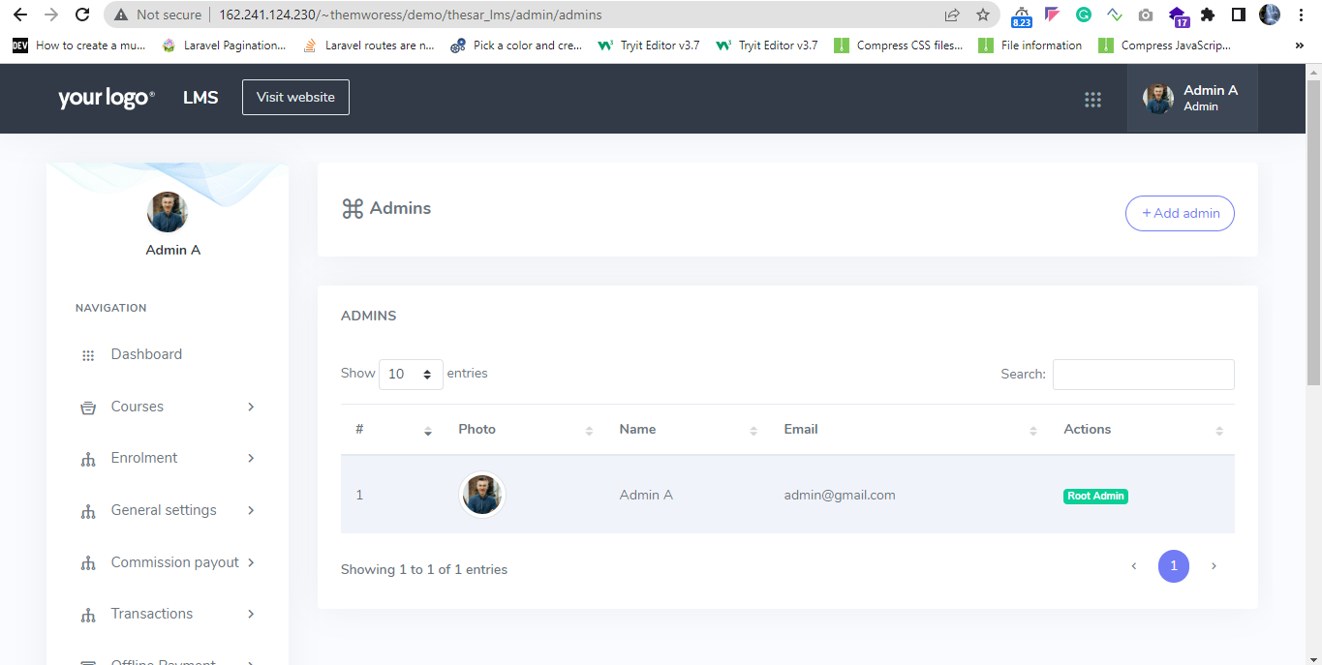
Instructors
5.4 Admin can manage instructors; the admin has control over all of the instructors and can remove them.
5.5 Admin can add new instructors. And edit the users.
5.6 Admin has access to all instructor payment requests that have he's submitted. He has the opportunity to approve payment requests and repay the instructor.
5.7 Instructor setting commission rates, permitting or disabling public instructors, and allowing or disabling general instructors may all be done here. Instructors get paid according to the preset commission rate by the admin.
5.8 Users can apply to become an instructor if the public instructor is enabled. The admin has the authority to accept or reject applications. Admin can approve the instructors list.
Status: Completed
URL: http://162.241.124.230/~themworess/demo/thesar_lms/admin/instructors
Screenshot:
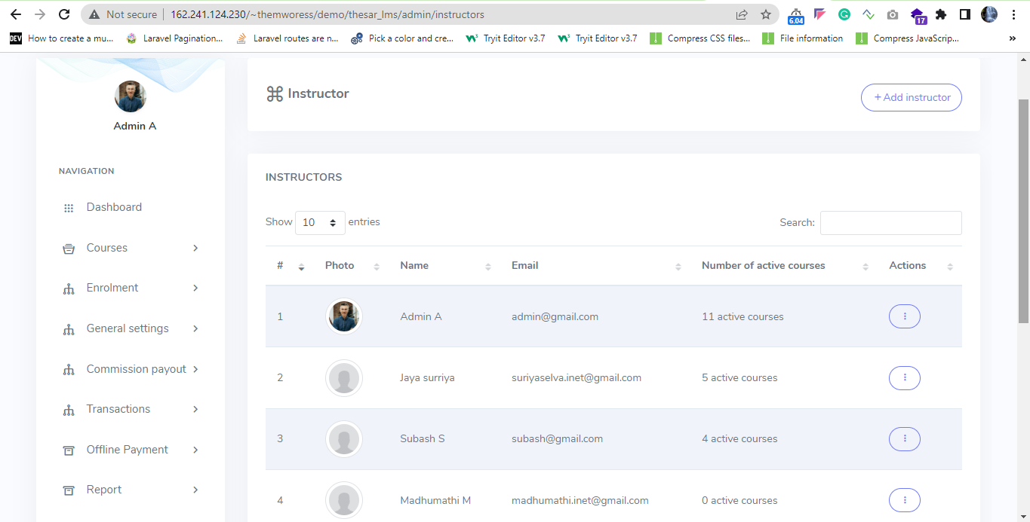

Student
5.9 Admin can view the list of enrolled students.
5.10 Admin can create a new student with the basic details and wallet address.
Status: Completed
URL: http://162.241.124.230/~themworess/demo/thesar_lms/admin/users
Screenshot:
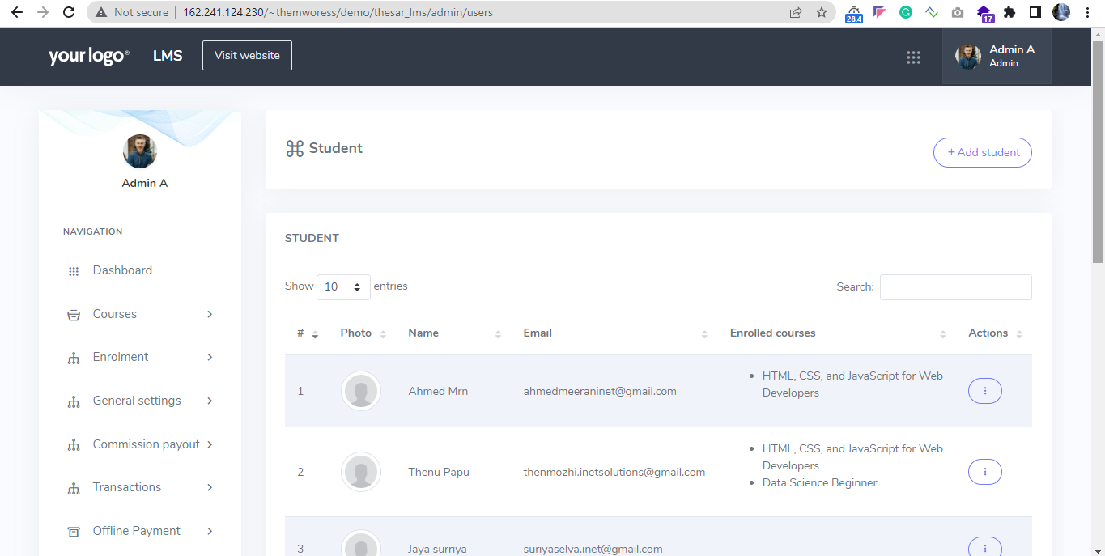
Admin can view the list of students and enrolled courses details.
6 Messages
6.1 Admin can communicate with all students and instructors using the LMS (Learning management system) internal messaging system.
6.2 Here admin can select the particular user to send messages or left side shows list of user, admin can directly click the user and send message.
Status: Completed
URL: http://162.241.124.230/~themworess/demo/thesar_lms/admin/message
Screenshot:
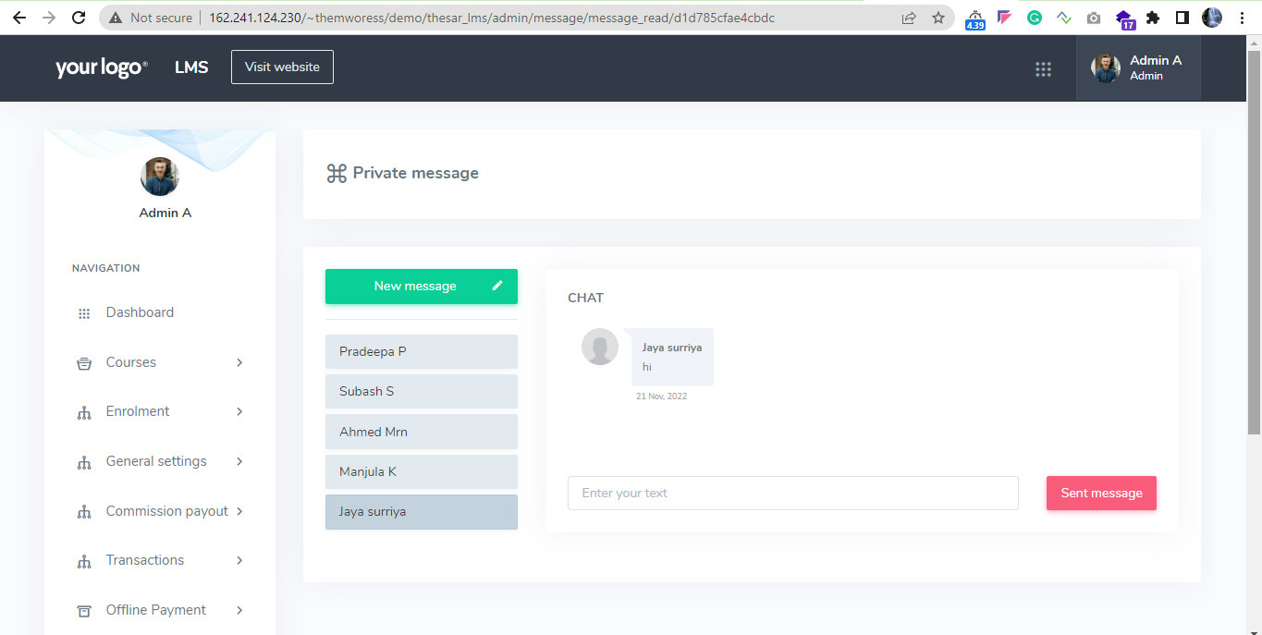
7 Blog
7.1 Admin can view all blog lists with category. Admin can add new blog, edit blog details.
7.2 Admin can edit the blog settings also.
Status: Completed
URL: http://162.241.124.230/~themworess/demo/thesar_lms/admin/blog
Screenshot:
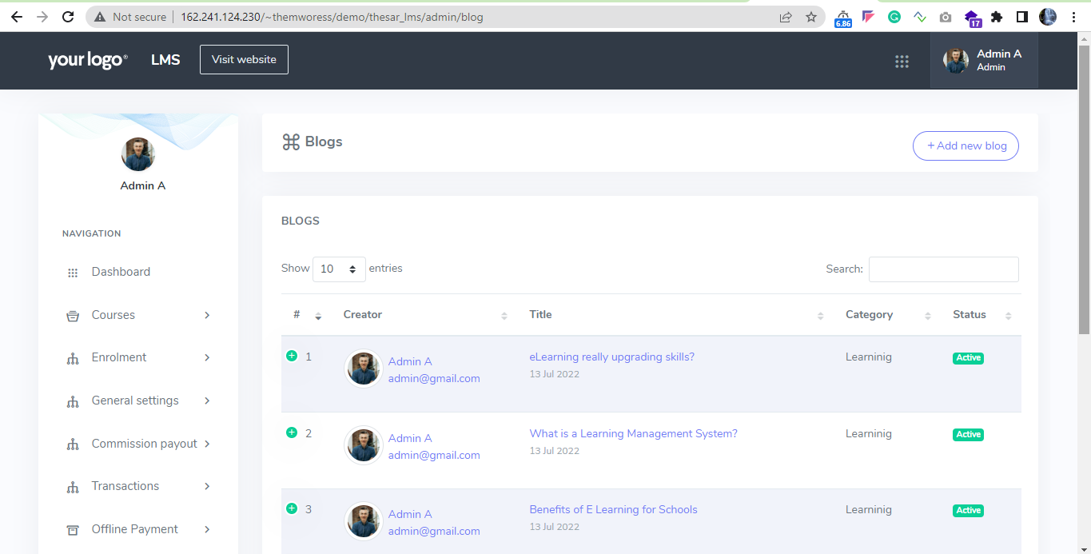

8 Settings
System settings
8.1 Admin can edit website's name, title, keywords, description, system email and address, course accessibility, footer text, footer link and system settings
8.2 Admin can update the product
Status: Completed
URL: http://162.241.124.230/~themworess/demo/thesar_lms/admin/system_settings
Screenshot:
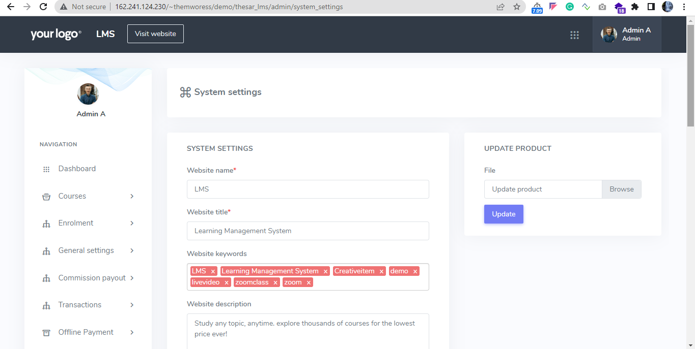
Website settings
8.3 The admin can change the Banner title, Banner subtitle, Cookie policy, About us, Terms and conditions, Privacy policy, Refund Policy, Re-captcha settings, etc. Can edit site logo and Favicon.
Status: Completed
URL: http://162.241.124.230/~themworess/demo/thesar_lms/admin/frontend_settings
Screenshot:
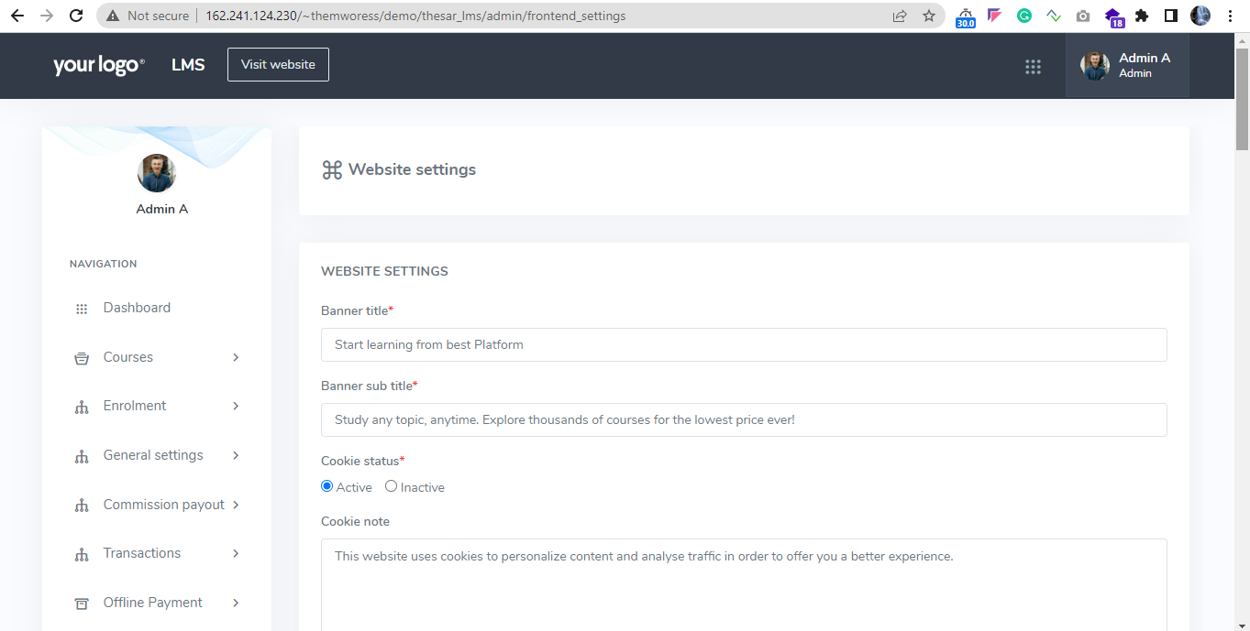
Drip content settings
8.4 Admin can manage drip content settings. Admin can set lesson completion role based on video percentage wise or video duration wise.
Status: Completed
URL: http://162.241.124.230/~themworess/demo/thesar_lms/admin/drip_content_settings
Screenshot:
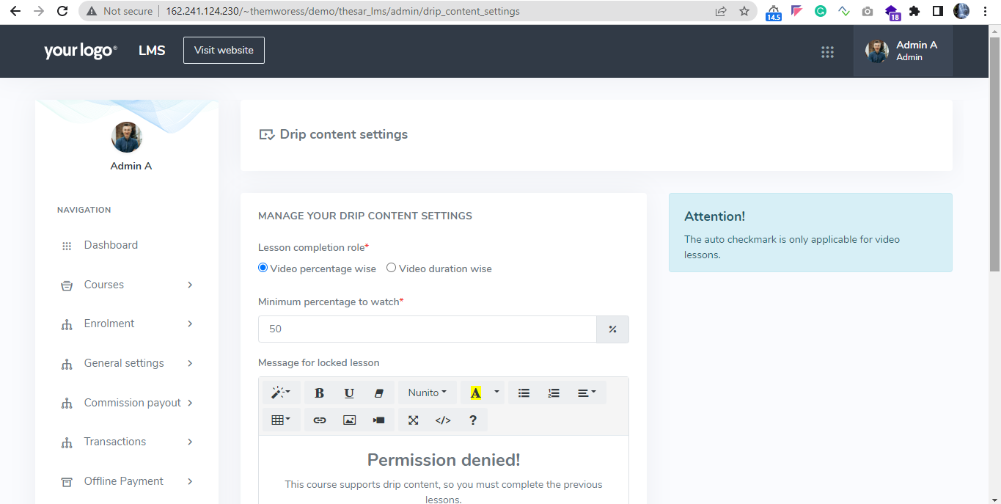
Payment settings
8.5 Admin can setup payment information details.
8.6 Admin can set currency details, position details.
8.7 Admin can edit system currency, currency position in this page.
Status: Completed
URL: http://162.241.124.230/~themworess/demo/thesar_lms/admin/payment_settings
Screenshot:
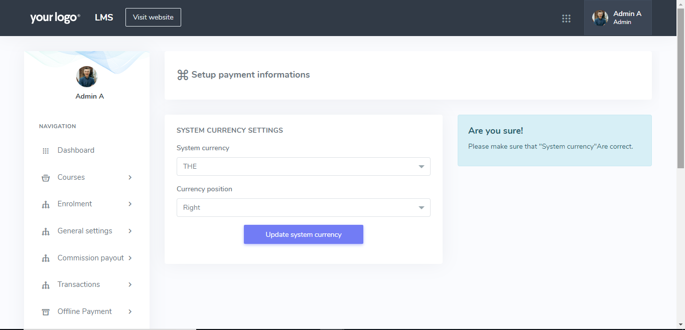

Live class settings
8.8 Admin can setup live class settings.
8.9 Admin can set zoom API keys, zoom secret keys.
Status: Completed
URL: http://162.241.124.230/~themworess/demo/thesar_lms/addons/liveclass/settings
Screenshot:
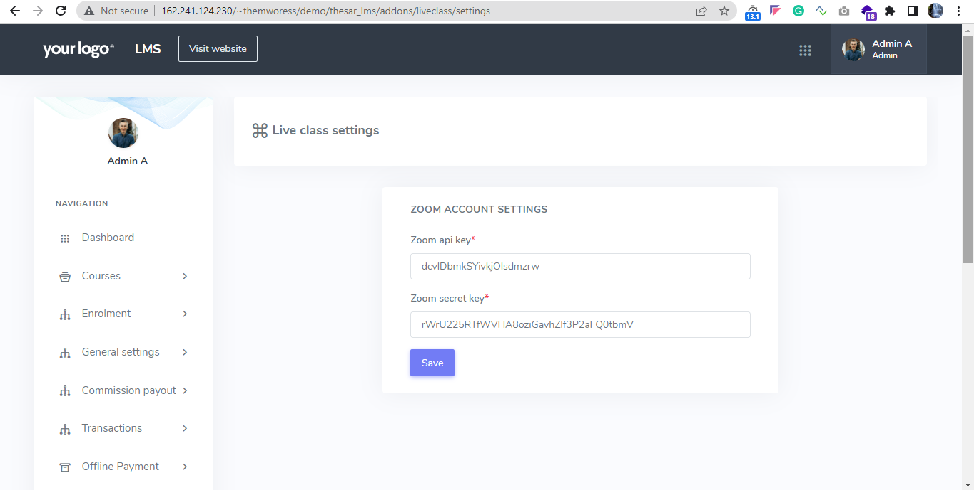
SMTP settings
8.10 Admin can edit the SMTP server detail settings.
Status: Completed
URL: http://162.241.124.230/~themworess/demo/thesar_lms/admin/smtp_settings
Screenshot:
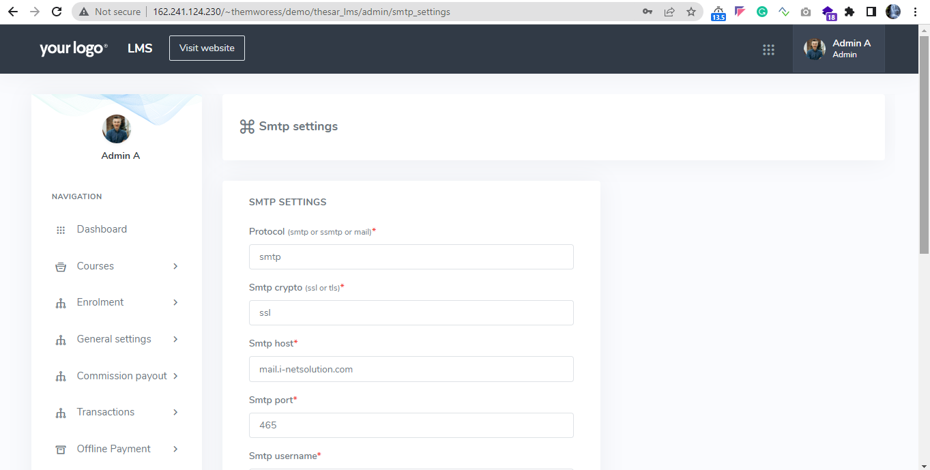
Social Login
8.11 Suppose the admin has set up social login. Users can log in to the academy using their Facebook accounts. Here admin can manage the social login details.
Status: Completed
URL: http://162.241.124.230/~themworess/demo/thesar_lms/admin/social_login_settings
Screenshot:
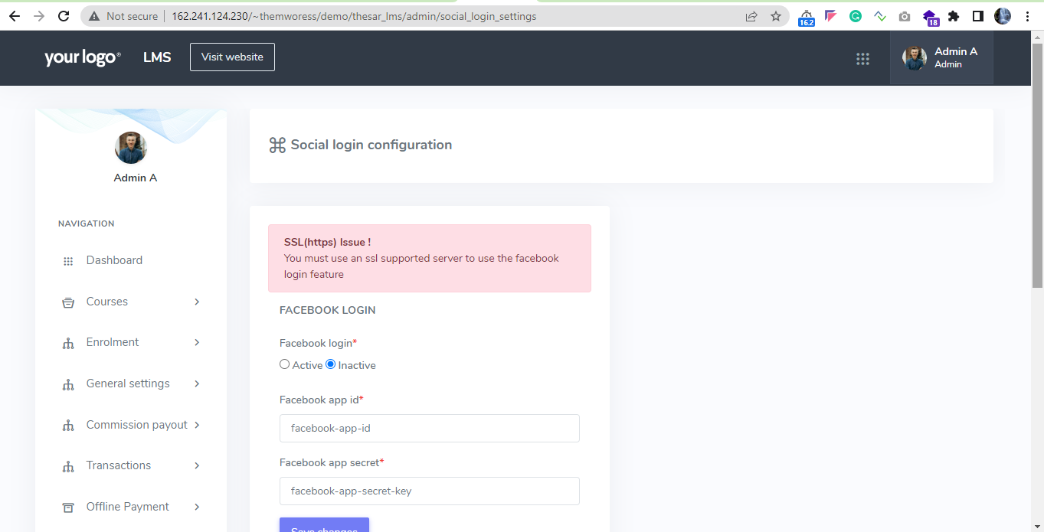
Custom pages
8.12 Here admin can add new pages, page title, button title, positions.
Status: Completed
URL: http://162.241.124.230/~themworess/demo/thesar_lms/admin/custom_page
Screenshot:
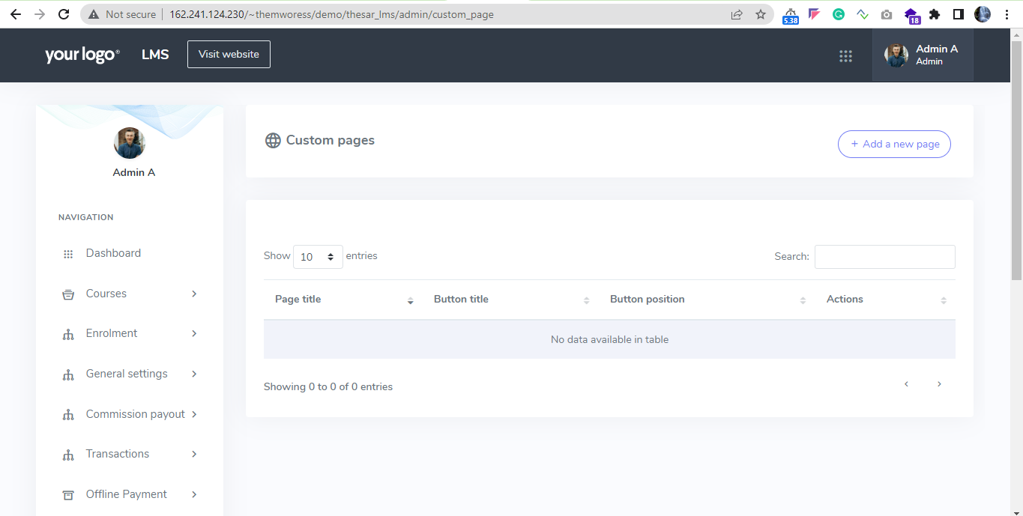
About page
8.13 Admin can see the learning management application details.
9 Manage Profile
9.1 Admin can update his data, skills, profile photo and password as a user.
9.2 Admin can change the password
Status: Completed
URL: http://162.241.124.230/~themworess/demo/thesar_lms/admin/manage_profile
Screenshot:
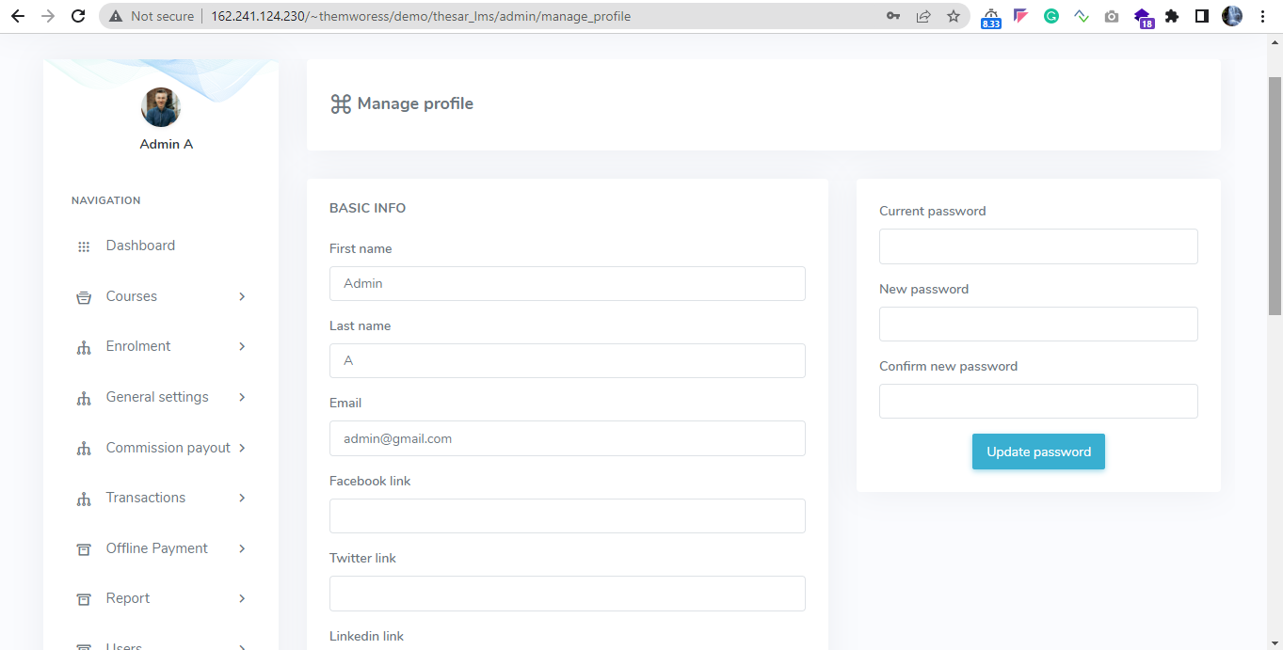

11 General Setting
11.1 General Plan
Admin can manage the coin name and coin rate, admin wallet address, INR rate, minimum withdraw amount, tds percentage, maximum user count per instructor, instruct percentage, certificate signature name details.
Admin can edit the all general settings details.
Status: Completed
URL: http://162.241.124.230/~themworess/demo/thesar_lms/admin/general_plan
Screenshot:
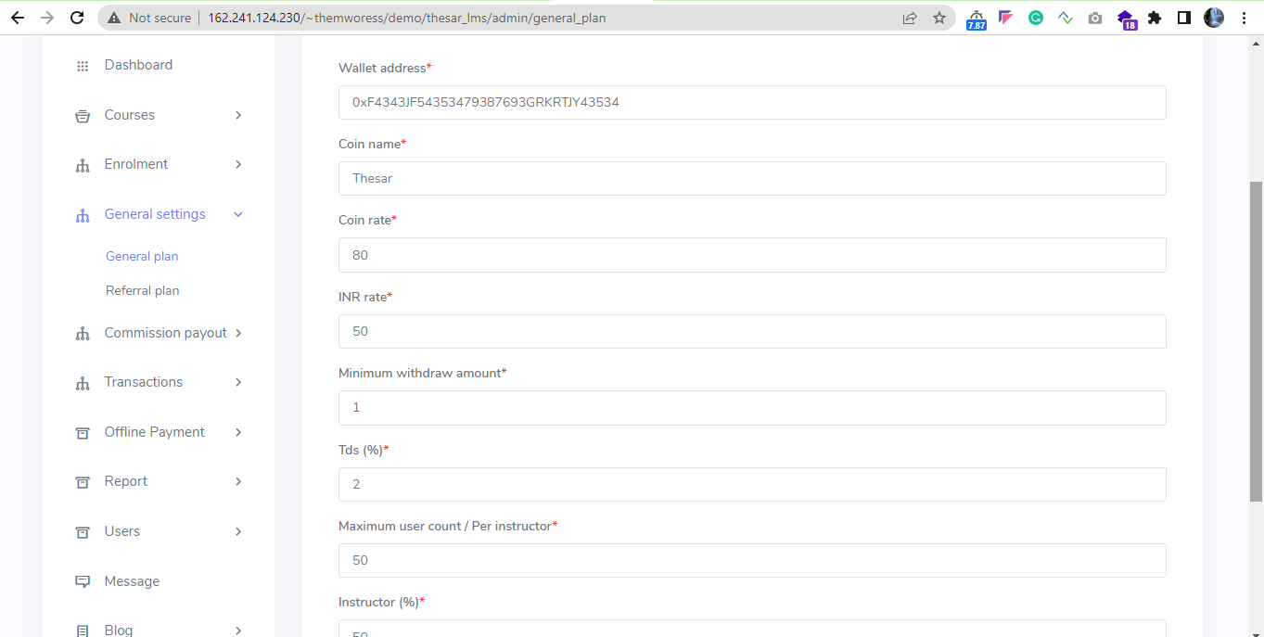

11.2 Referral Plan
Admin can manage referral commission percentage, admin can edit details.
Status: Completed
URL: http://162.241.124.230/~themworess/demo/thesar_lms/admin/referral_plan
Screenshot:
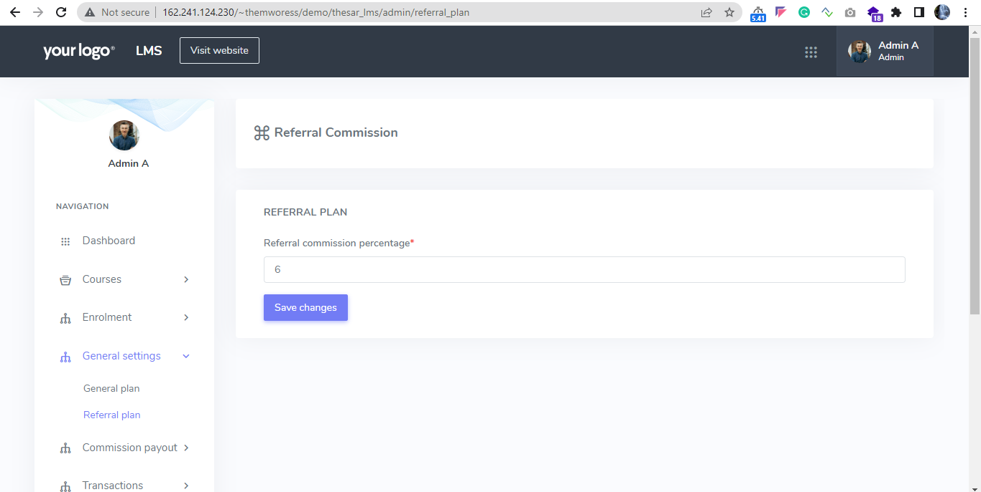

12 Commission Payout
12.1 Referral Commission
Admin can view the list of referral commission, from is and user id, amount, and date.
Status: Completed
URL: http://162.241.124.230/~themworess/demo/thesar_lms/admin/referral_commission
Screenshot:
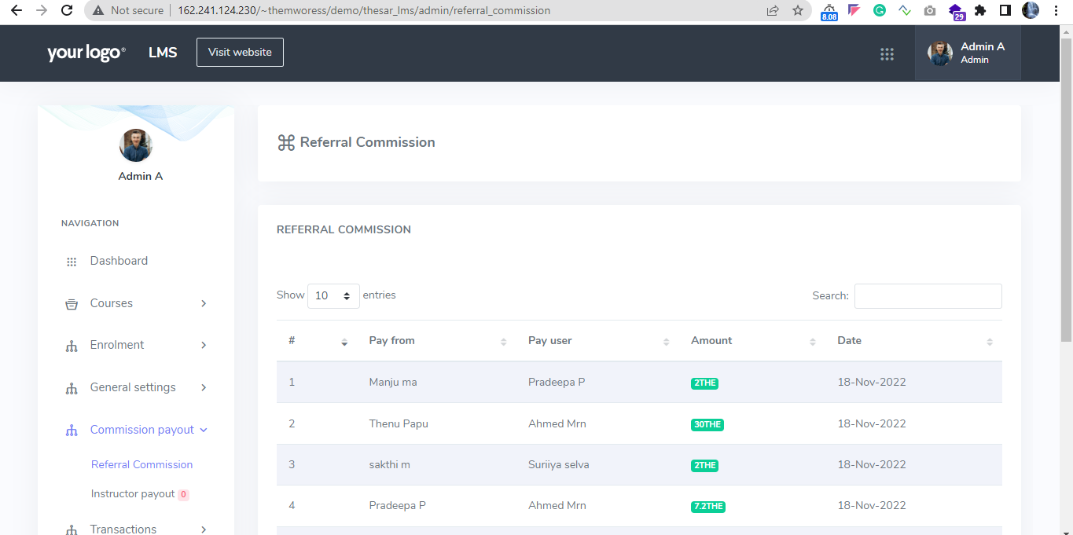

12.2 Instructor Payout
Admin can view instructor or completed payout, pending payout from the instructor.
Status: Completed
URL: http://162.241.124.230/~themworess/demo/thesar_lms/admin/instructor_payout
Screenshot:
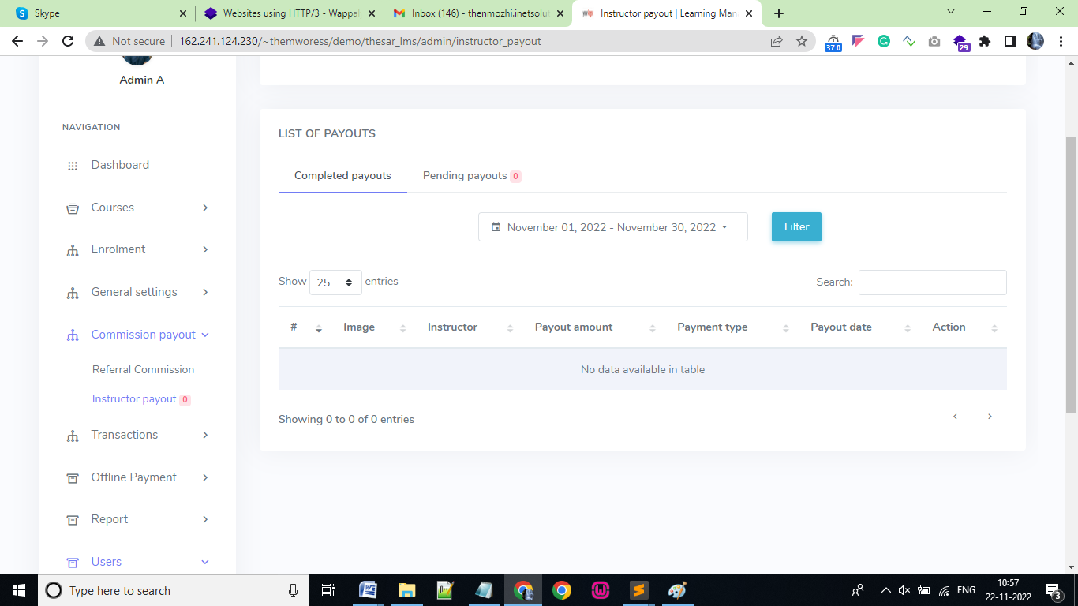

13 Withdrawal request
13.1 Withdrawal request
Admin can view the list of all withdrawal requests from the user or students.
Here admin can approve or reject the withdraw request from the user.
Status: Completed
URL: http://162.241.124.230/~themworess/demo/thesar_lms/admin/withdrawal_request
Screenshot:
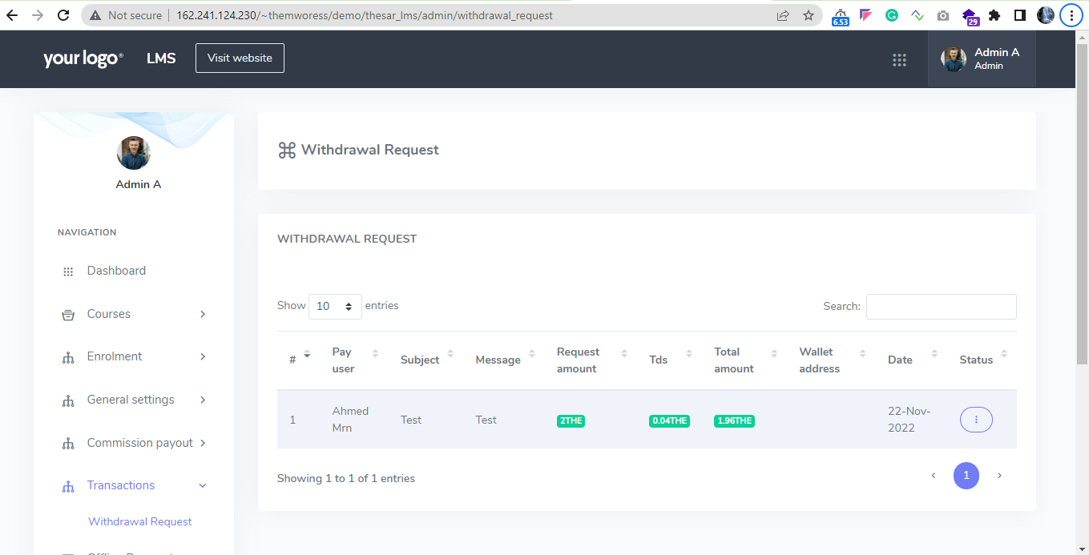

14 Offline payment
14.1 Offline payment
Admin can view the list of all offline payment requests from the user.
Check the attachment and approve or reject the payment process.
Status: Completed
URL: http://162.241.124.230/~themworess/demo/thesar_lms/admin/pending_request
Screenshot:
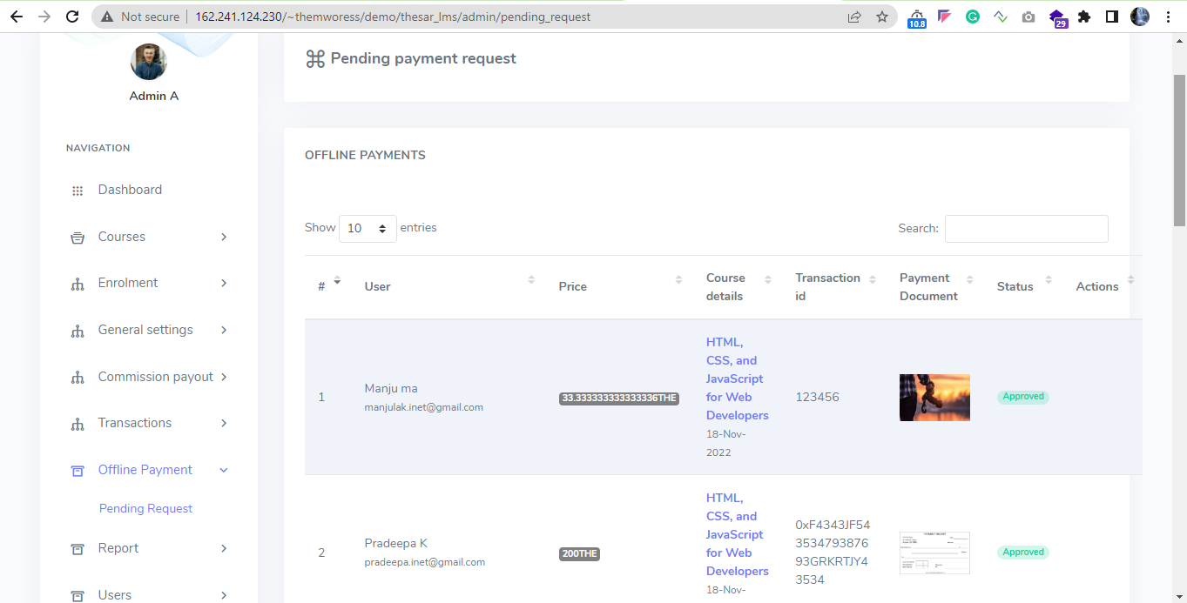
View the attached document and verify the request.

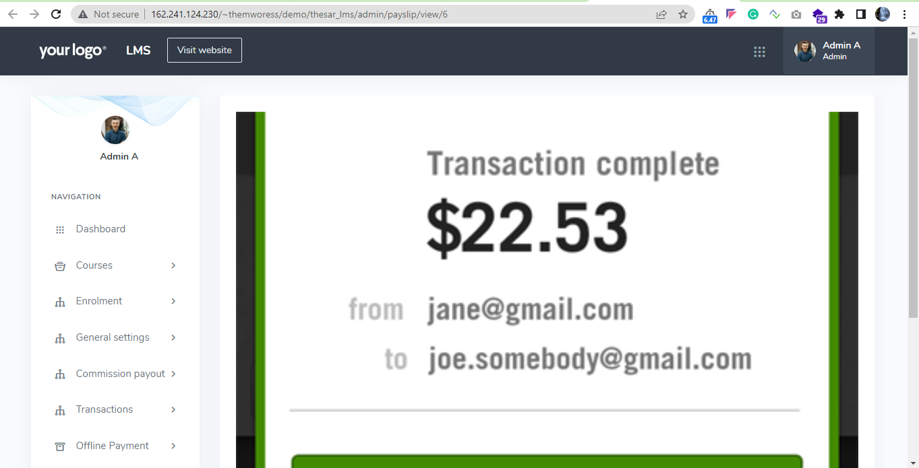

USER PAGE:
- Registration

    - New users can register with basic details.
    - The new user verification process.
    - Enter all the basic details of the user.
    - Once the registration process is over, a confirmation email will be sent to the user with a link to activate the account.
    - Through referral link user can register the account.
Status: Completed
URL: http://162.241.124.230/~themworess/demo/thesar_lms/home/sign_up
Screenshot:
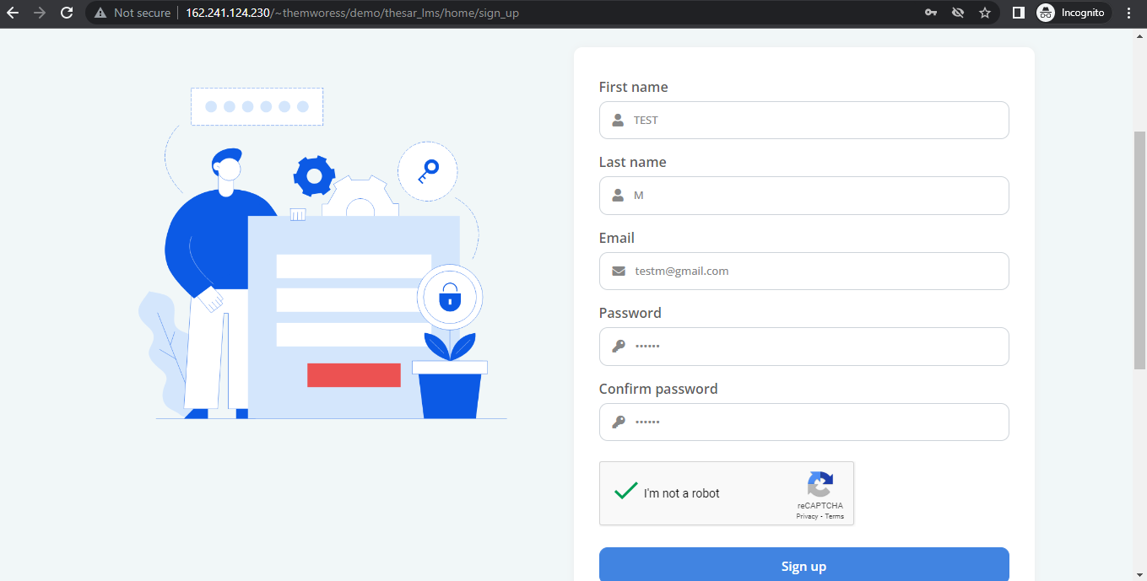

- Login
    - Users can log in via valid email, password, and Google re-captcha option.
    - User has the option of forgetting the password to recover their account.
Status: Completed
URL: http://162.241.124.230/~themworess/demo/thesar_lms/home/login
Screenshot:
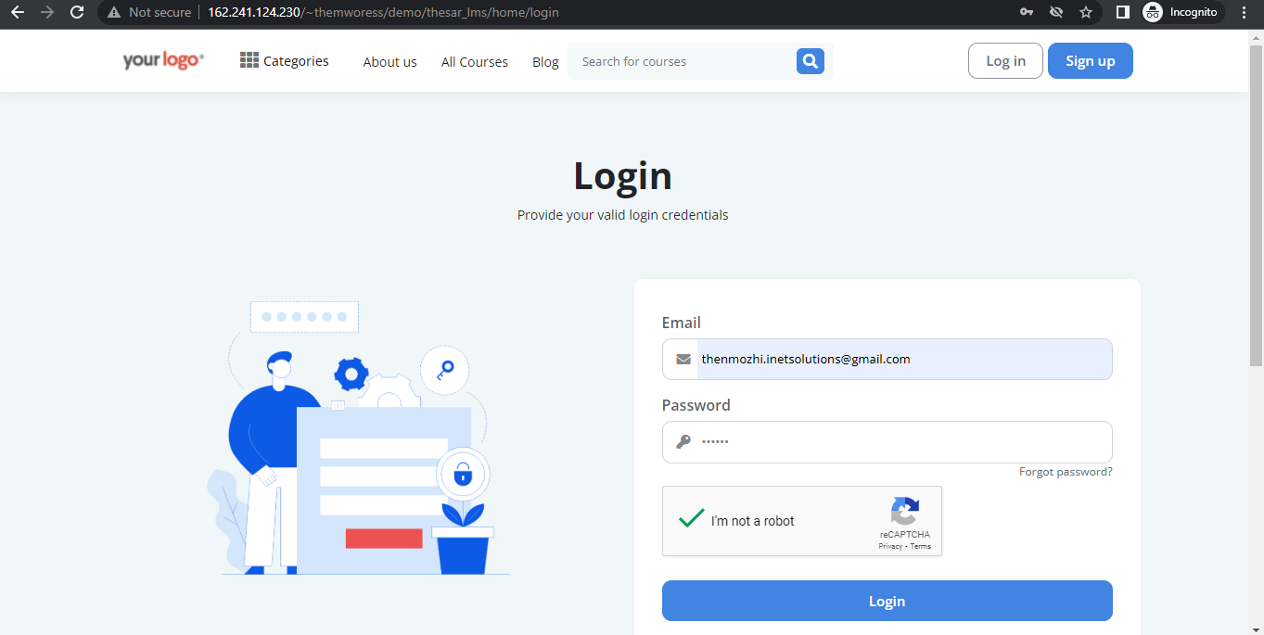
3 Course details
3.1.1 Student can view the all course details, paid course, free course, wish list page, my courses, messages, purchase history, and user profile
3.1.2 Student can purchase the courses via offline payment.
3.1.3 Registered and non-registered user view the full course details.
Status: Completed
URL: http://162.241.124.230/~themworess/demo/thesar_lms/home/courses
Screenshot:
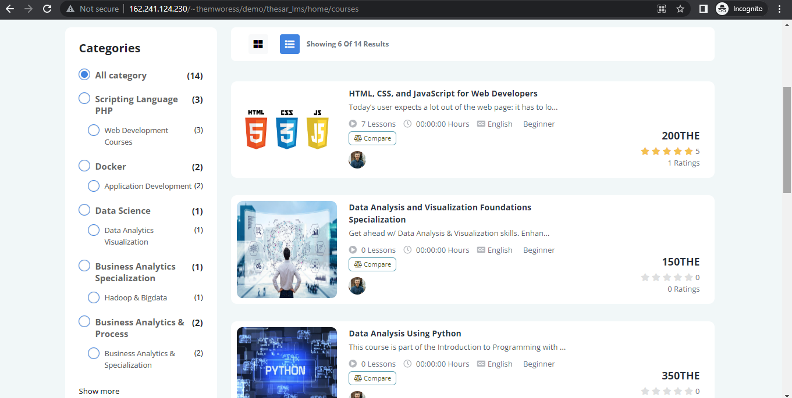

4 Profile management
4.1.1 User can edit their personal details, Biography, social links and so on.
4.1.2 Can edit account information, User can upload photo.
4.1.3 Can view and edit wallet address details, referral link.
Status: Completed
URL: http://162.241.124.230/~themworess/demo/thesar_lms/home/profile/user_profile
Screenshot:
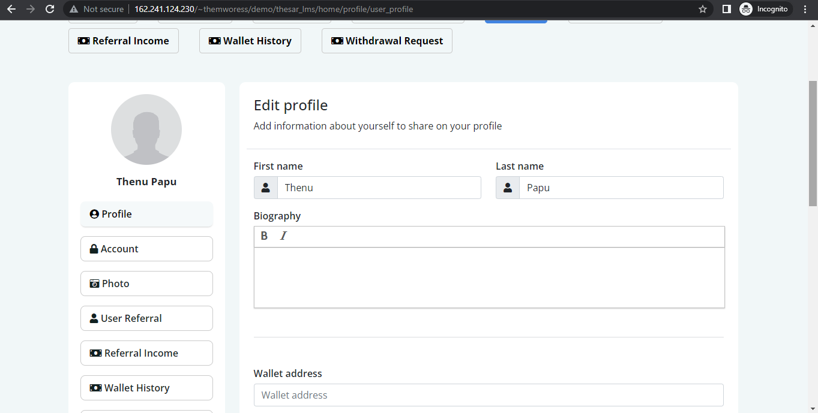
4.1 Courses
User can view the list of all purchased course details.
Status: Completed
URL: http://162.241.124.230/~themworess/demo/thesar_lms/home/my_courses
Screenshot:
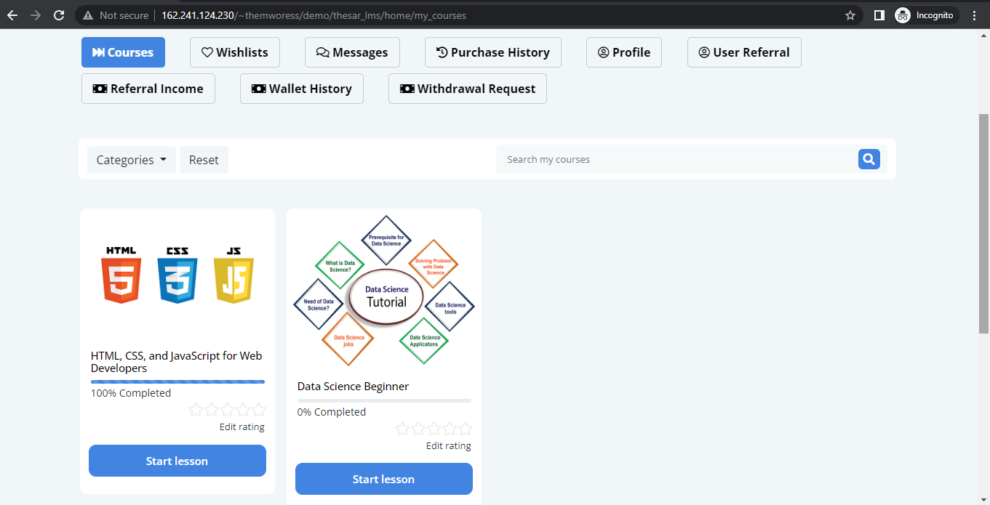
4.2 Wish lists
User can view their favourite course list and details, Can search the wish lists courses details also.
Status: Completed
URL: http://162.241.124.230/~themworess/demo/thesar_lms/home/my_wishlist
Screenshot:
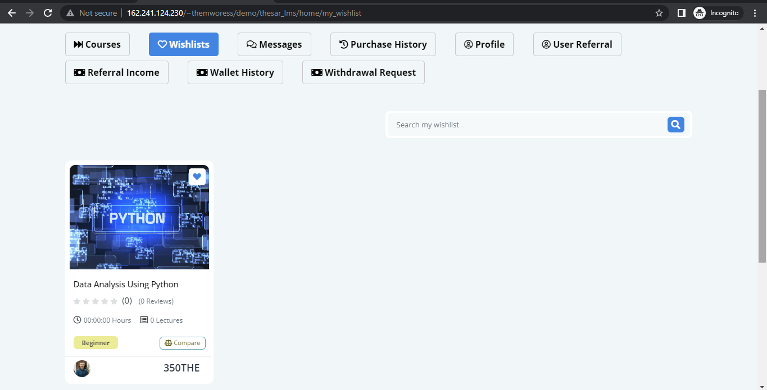
4.3 Messages
Here user can send and receive message to admin and other user also. User can send message to their purchased course instructors.
Status: Completed
URL: http://162.241.124.230/~themworess/demo/thesar_lms/home/my_messages/read_message/e649167ef3ed0be
Screenshot:

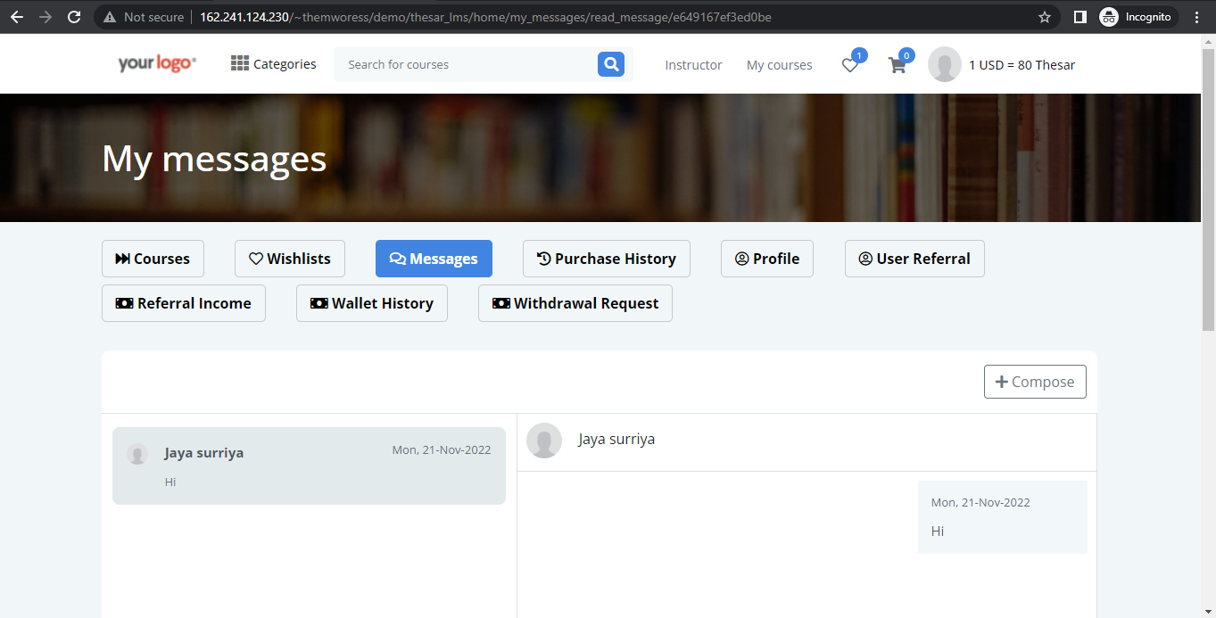
4.4 Purchase history
Student view the list of purchased courses details, payment type and invoice. User can print Invoice details.
Student can view pending, declined and approved purchased courses details.
Status: Completed
URL: http://162.241.124.230/~themworess/demo/thesar_lms/home/purchase_history
Screenshot:
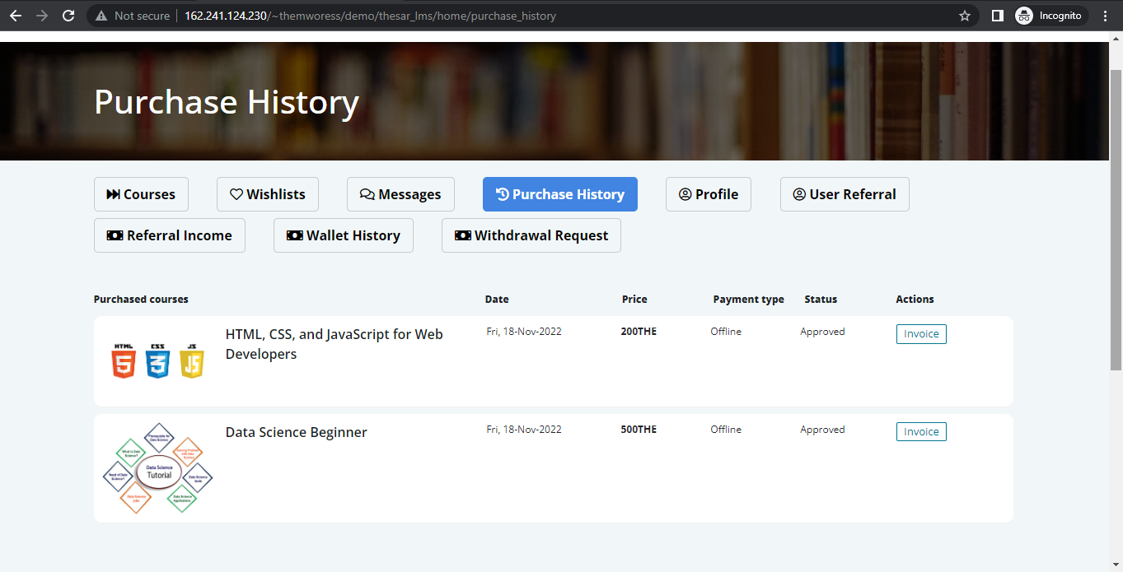
4.5 Profile
User can view basic details, account information, profile photo upload, Social media link and referral link.
Status: Completed
URL: http://162.241.124.230/~themworess/demo/thesar_lms/home/profile/user_profile
Screenshot:
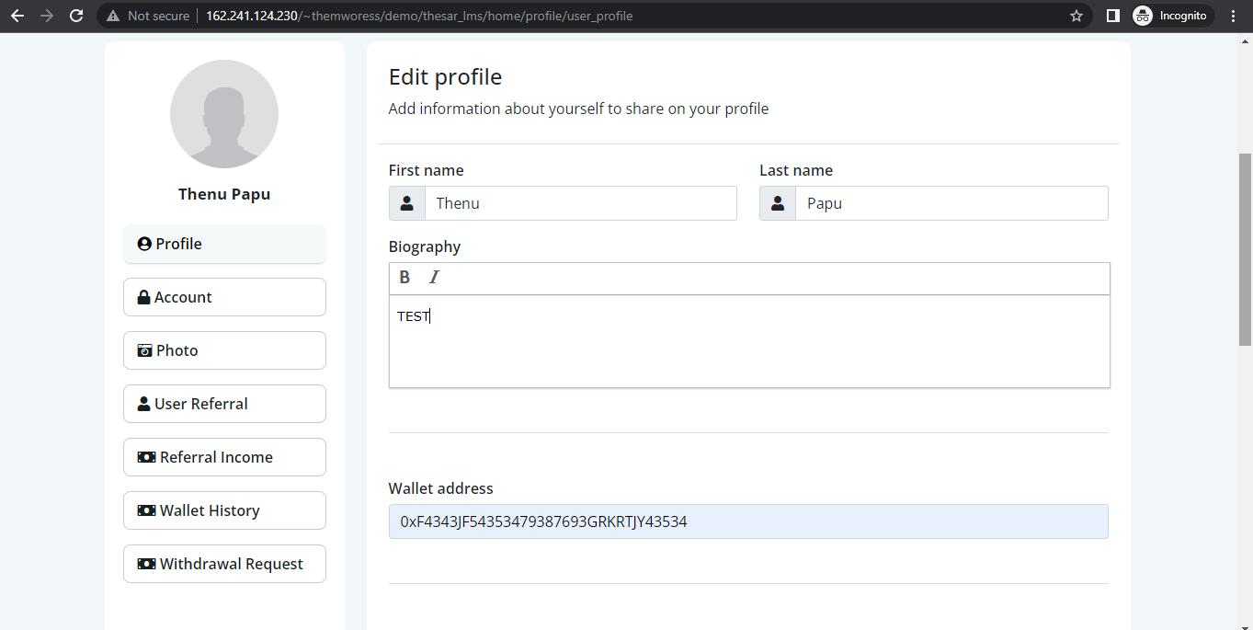

4.6 Referral list
It shows the list of referral list details. User can view their referrals basic details and active status also.
Status: Completed
URL: http://162.241.124.230/~themworess/demo/thesar_lms/home/profile/user_referral
Screenshot:
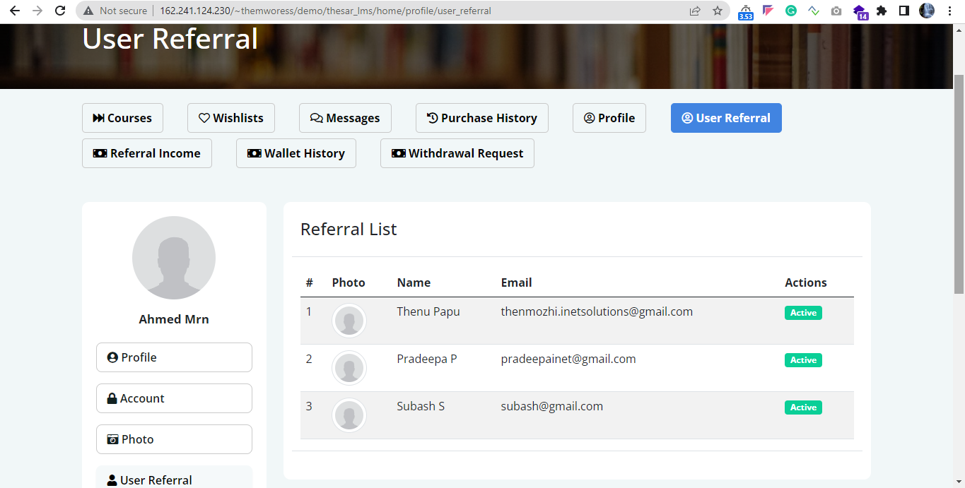

4.7 Referral Income
User’s referral income details like from user details, amount and the date of referral income received.
Status: Completed
URL: http://162.241.124.230/~themworess/demo/thesar_lms/home/profile/referral_income
Screenshot:
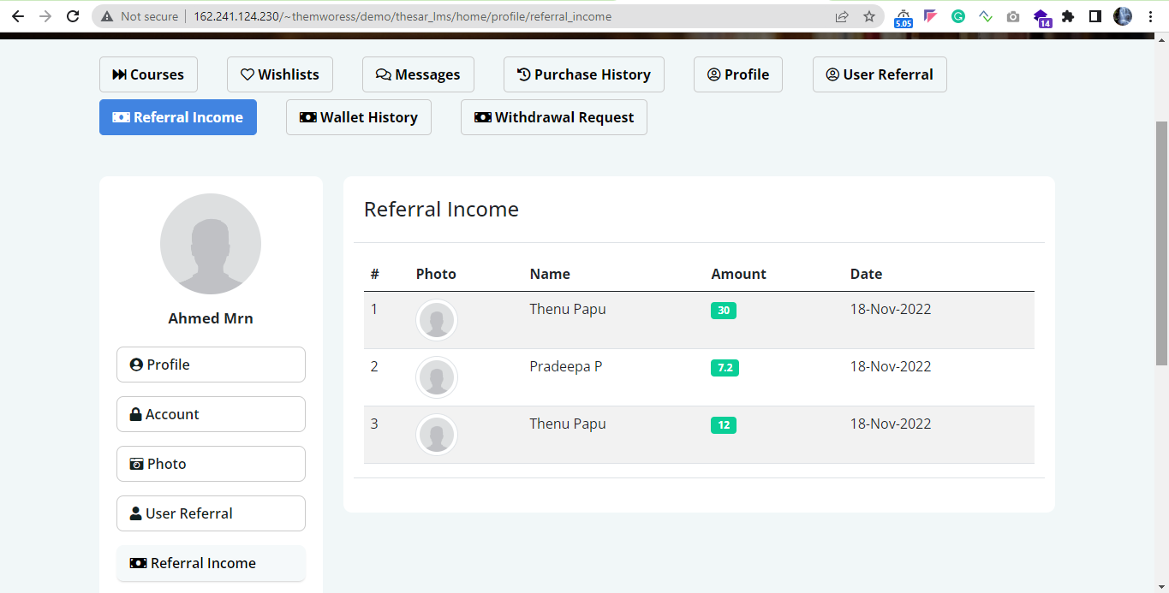
4.8 Wallet history
User can view the list of wallet history details and balance amount.
User can view if the amount is credited or debited from my amount, and shows the balance amount.
Status: Completed
URL: http://162.241.124.230/~themworess/demo/thesar_lms/home/profile/wallet_history
Screenshot:
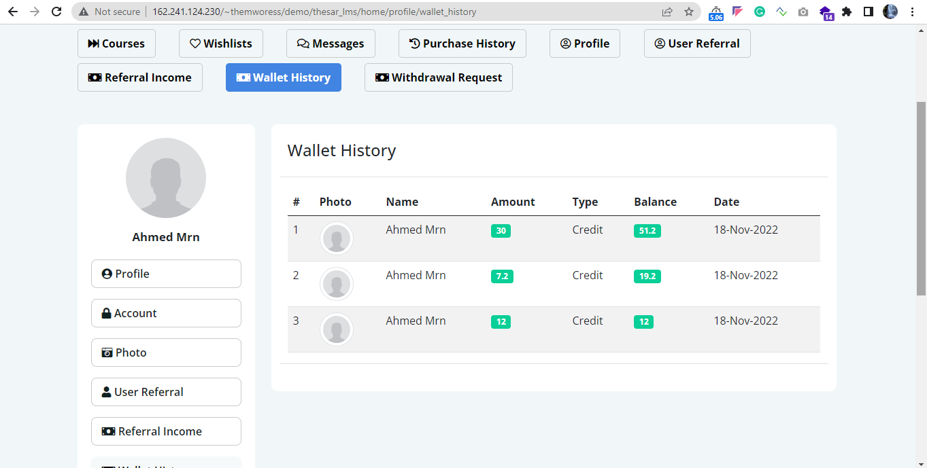

4.8 Withdrawal request
User can view the list of wallet send withdraw details from the user.
Request amount, message from the withdraw requester and view the status of request. Admin is approved or rejected.
Status: Completed
URL: http://162.241.124.230/~themworess/demo/thesar_lms/home/profile/withdrawal_request
Screenshot:
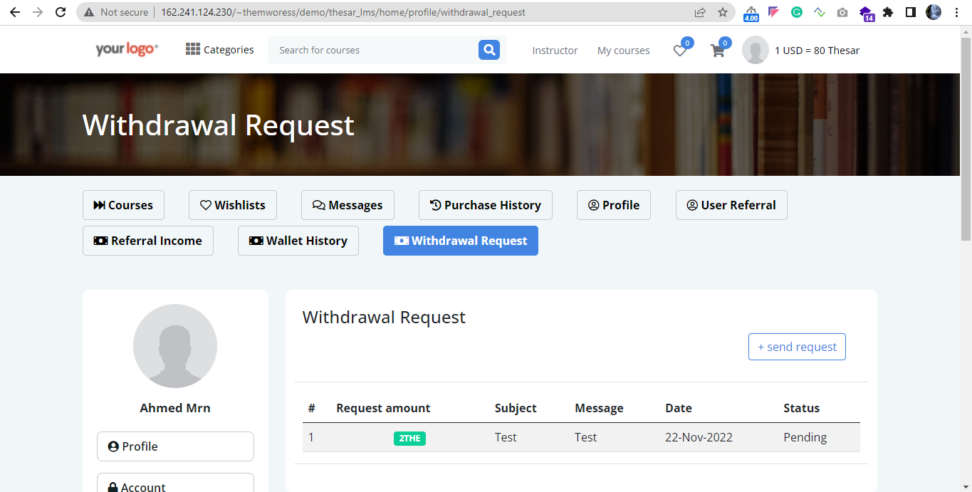

4.8 Send withdraw request
User can send the withdraw request, In this page user can view the available income, minimum amount of withdraw request.
Status: Completed
URL: http://162.241.124.230/~themworess/demo/thesar_lms/home/profile/send_request
Screenshot:
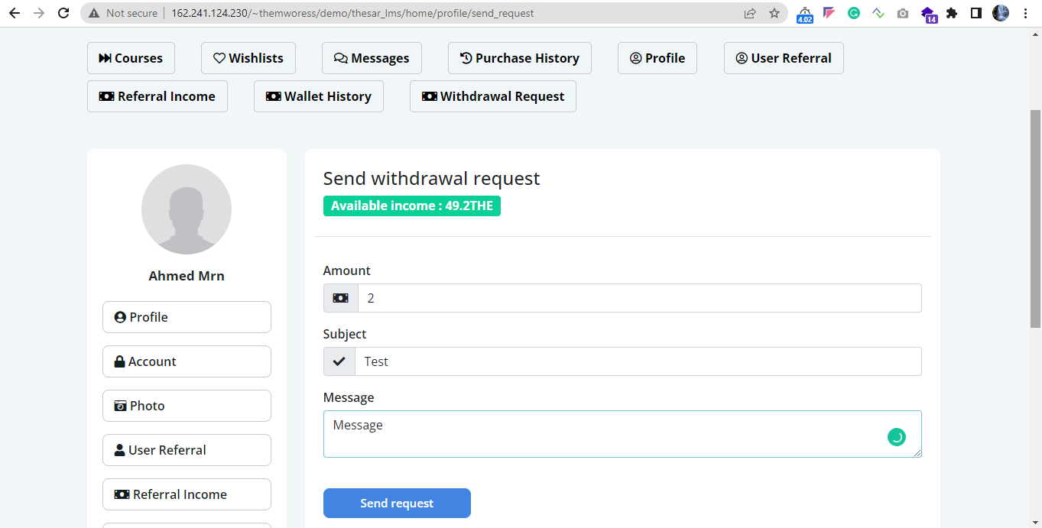
4.9 Currency convertor
Registered and non registered user can check the equivalence of USD and INR value.
User can check the entire course information page.
Status: Completed
URL: http://162.241.124.230/~themworess/demo/thesar_lms/home/course/data-analysis-and-visualization-foundations-specialization/3
Screenshot:
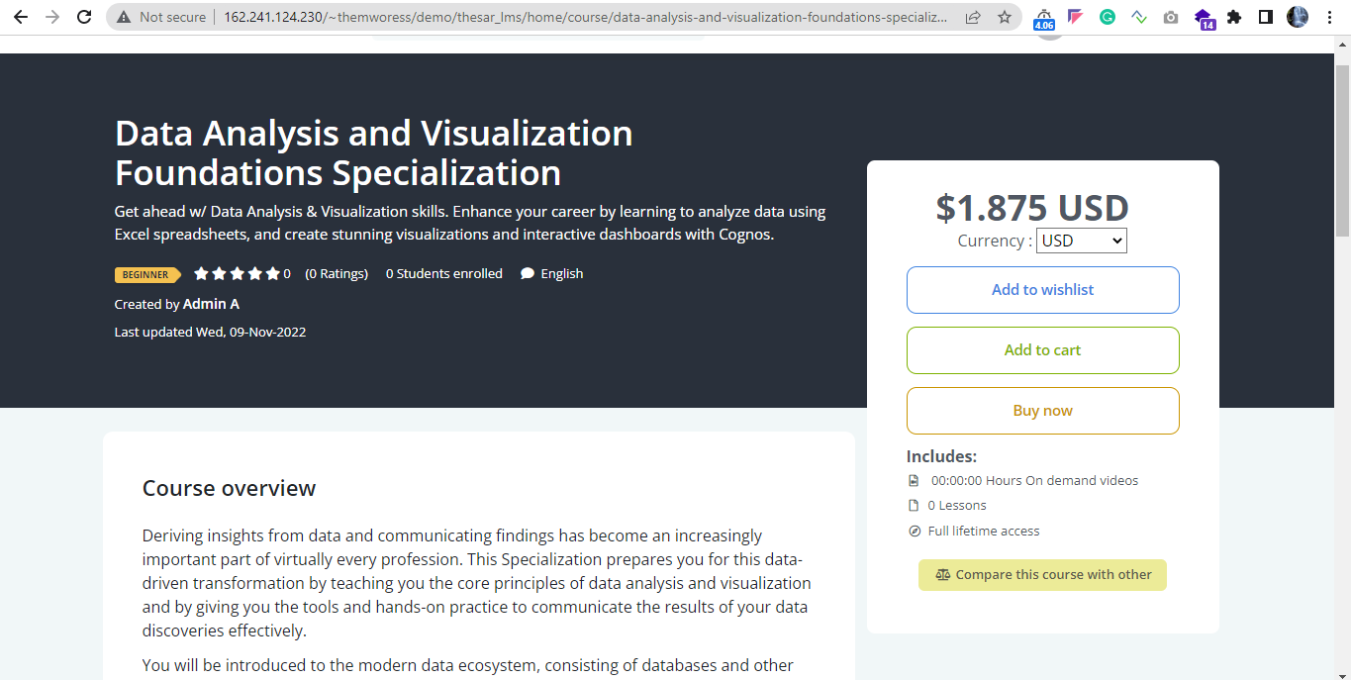

4.10 Offline payment
User can purchase the course through offline payment. Attach payslip, transaction id.
Select payment type and complete the offline payment request, once the admin approve the payment request user can view their purchased courses.
Status: Completed
URL: http://162.241.124.230/~themworess/demo/thesar_lms/home/payment
Screenshot:
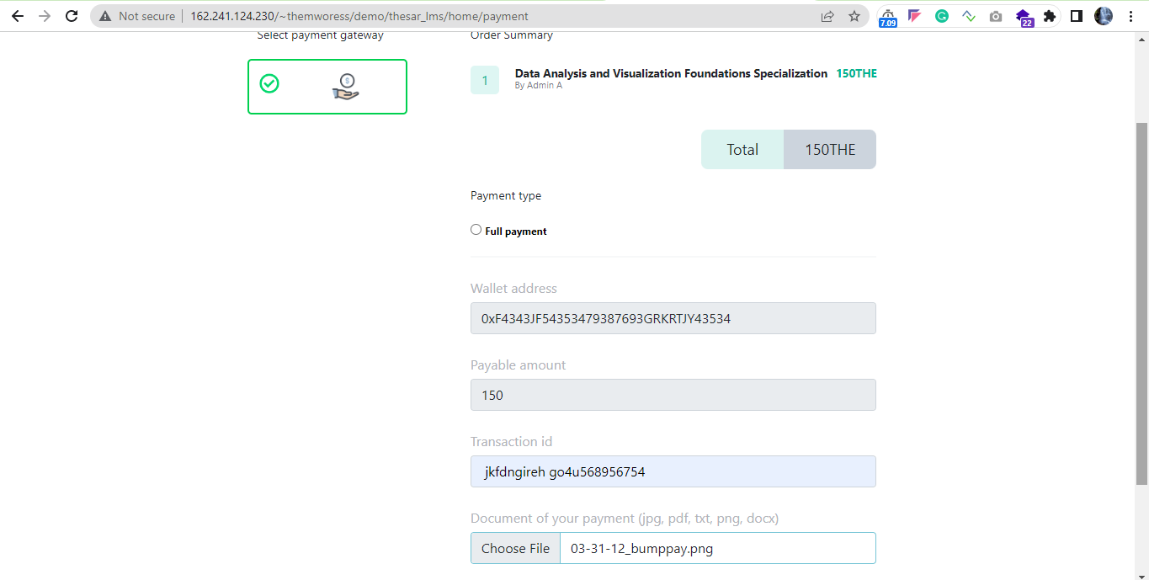

LANDING PAGE:
- Home page

Users may access the view pages without logging in.

When users access the landing page, they will see the Course Search option on the home page and see the top courses and the top 10 latest courses.

On the home page are featured top courses. Users quickly find suitable courses.

Latest courses added to the homepage. Users can select the most recent courses and purchases by signing up.

User can filter categories, price, level, language, usage courses before signing up to learning management system and purchasing courses.

The user wants to see all the courses on the course page in a list; they can see it using the list icon. User can change the grid view also.

Status: Completed
URL: http://162.241.124.230/~themworess/demo/thesar_lms/

Screenshot:
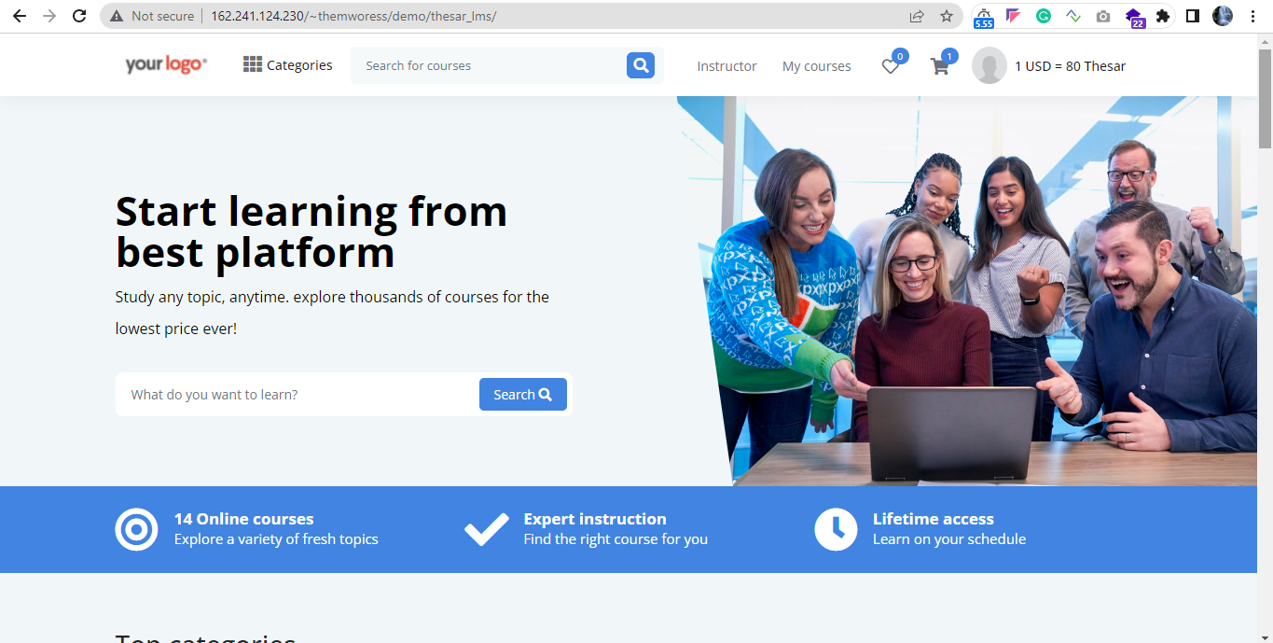

- Course categories menu
2.1 A course menu with a drop-down menu includes categories and subcategories.
2.2 Category and subcategory select a specific category. User can view all courses in the department at once.

Status: Completed
URL: http://162.241.124.230/~themworess/demo/thesar_lms/home/courses
Screenshot:
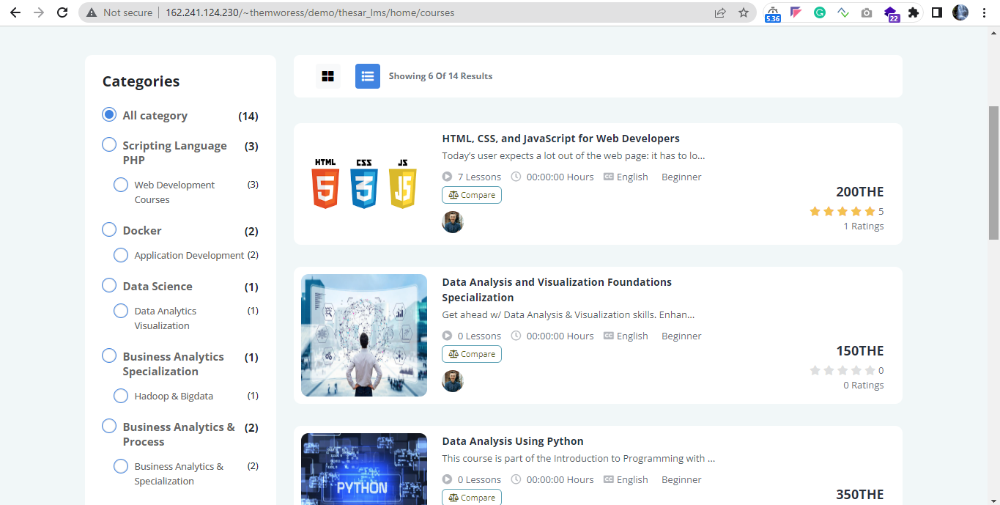

  - Based on price, level of courses, language and based on ratings user can filter the courses
Status: Completed
URL: http://162.241.124.230/~themworess/demo/thesar_lms/home/courses
Screenshot:
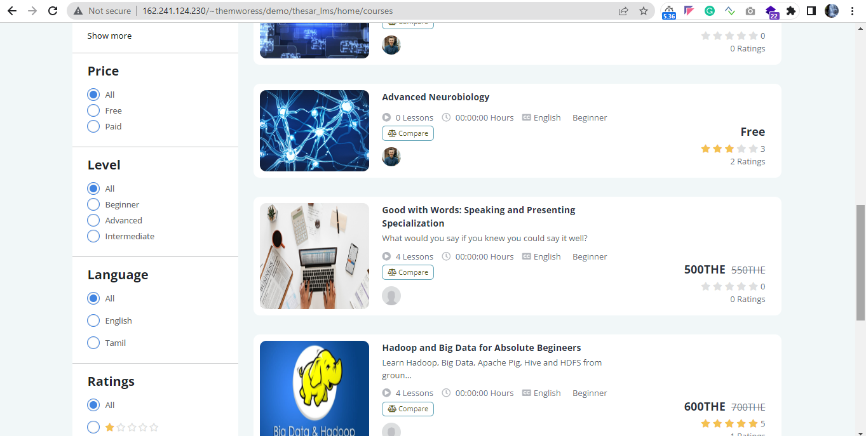

3. Course search bar
3.1 Users can find a course using the search box above. User can use the search bar to locate the required courses
Status: Completed
URL: http://162.241.124.230/~themworess/demo/thesar_lms/
Screenshot:
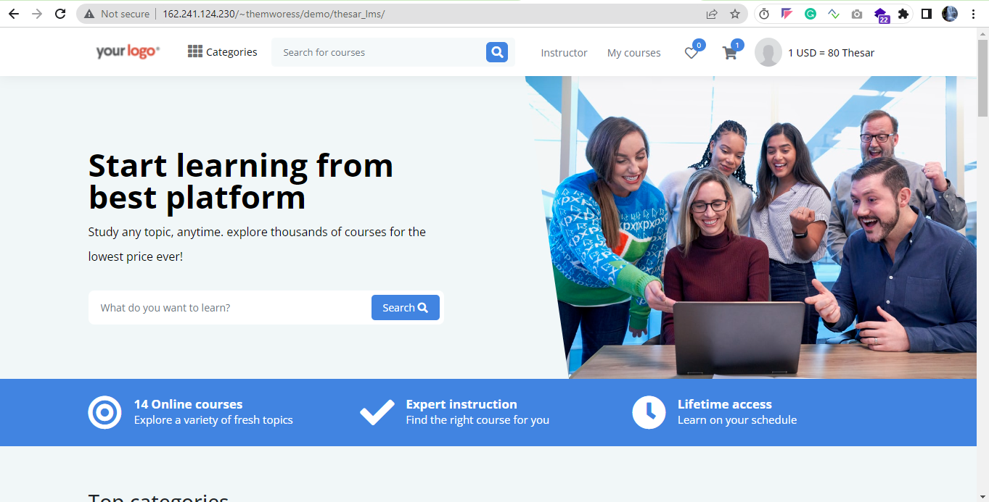

- Cart Page
4.1 When users add their favourite courses to their add to cart, the cart page displays all the courses added to their add to cart.
Status: Completed
URL: http://162.241.124.230/~themworess/demo/thesar_lms/home/shopping_cart
Screenshot:
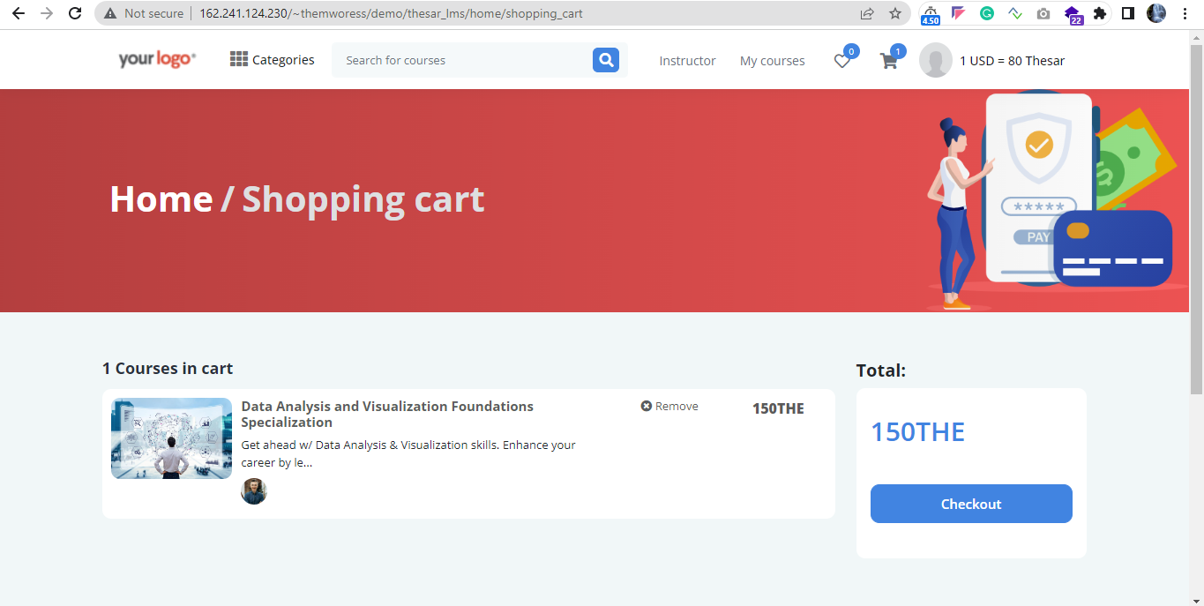

- Signup Page
  - User can sign up with basic details. Enter all the basic details of the user.
  - Through referral link also user can register
Status: Completed
URL: http://162.241.124.230/~themworess/demo/thesar_lms/home/sign_up/2
Screenshot:
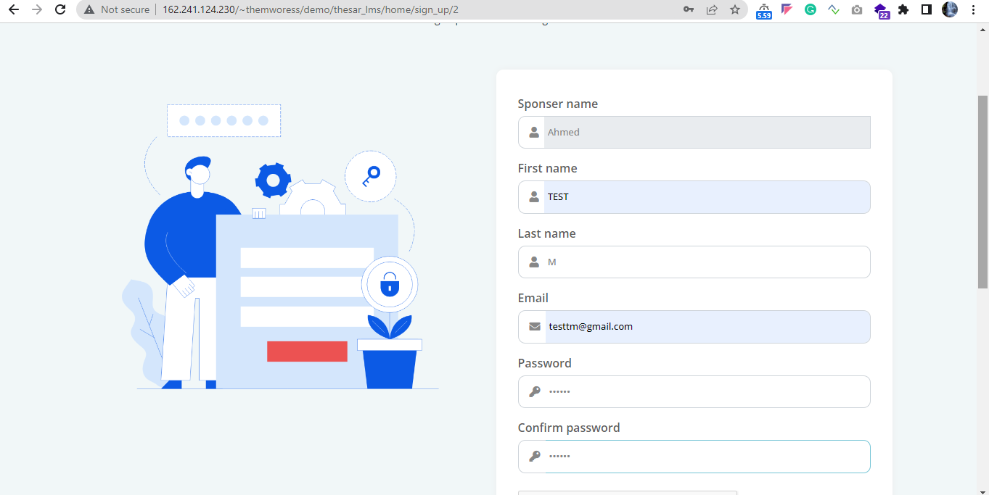
- Login Page
  - If a user already has an account, they do not need to sign up again. Users can purchase the course if they have an account.
  - User can login via Users can log in via valid email, password, and re-captcha option.
Status: Completed
URL: http://162.241.124.230/~themworess/demo/thesar_lms/home/login
Screenshot:
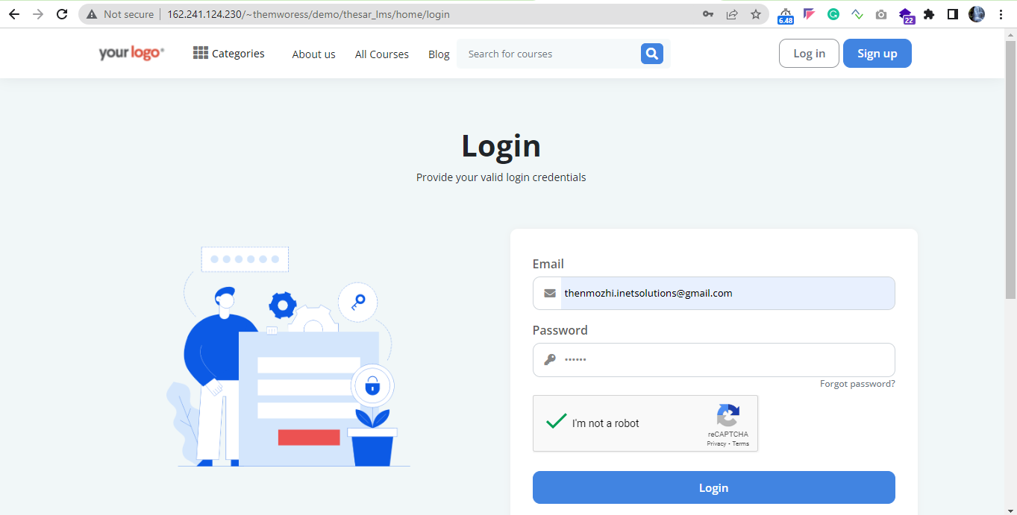

- Course details page
  - Users can the course details page.
  - Course ratings, curriculum, course requirements, course description, course previews, and can learn about the instructor without signing up.
Status: Completed
URL: http://162.241.124.230/~themworess/demo/thesar_lms/home/course/html-css-and-javascript-for-web-developers/1
Screenshot:
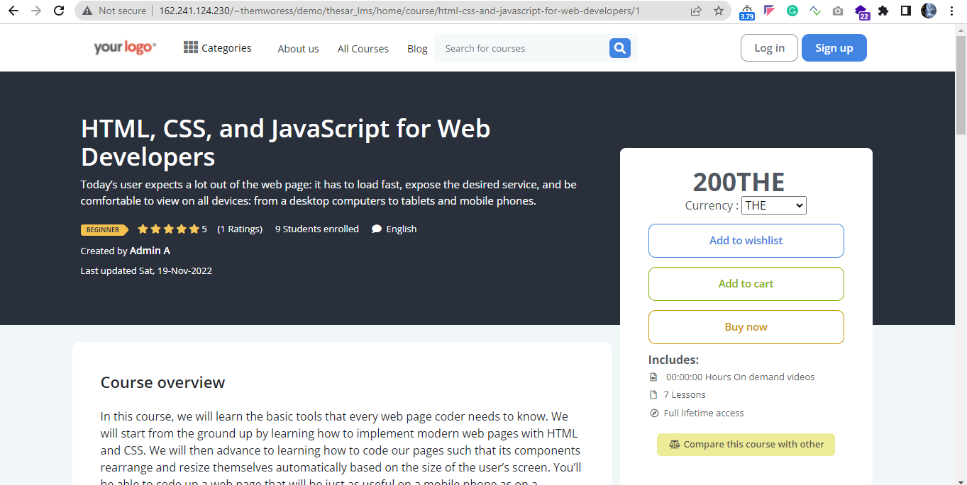

8. About us page
8.1 User can learn about the learning management system application without signing up by menu.
Status: Completed
URL: http://162.241.124.230/~themworess/demo/thesar_lms/home/about_us
Screenshot:
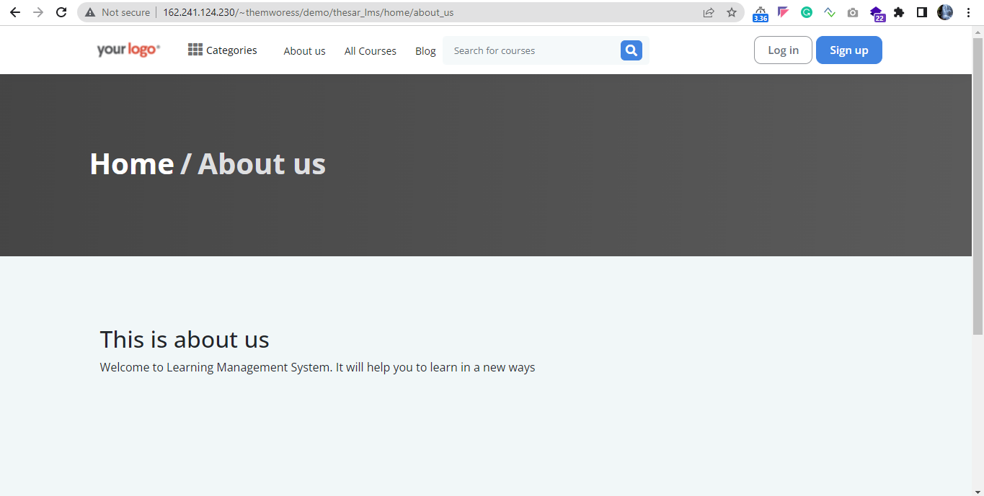
9. Privacy Policy
9.1 User can check the learning management system application’s privacy policy through this link.
Status: Completed
URL: http://162.241.124.230/~themworess/demo/thesar_lms/home/privacy_policy
Screenshot:
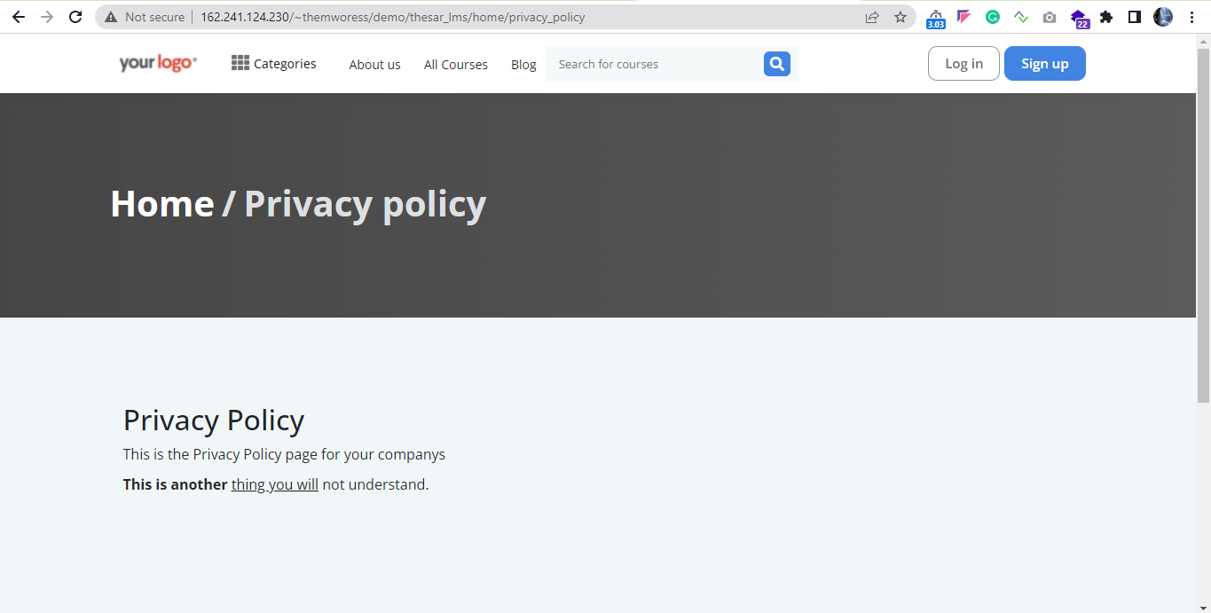

10. Terms and condition
10.1 User can able to view terms and conditions details page through this link.
Status: Completed
URL: http://162.241.124.230/~themworess/demo/thesar_lms/home/terms_and_condition
Screenshot:
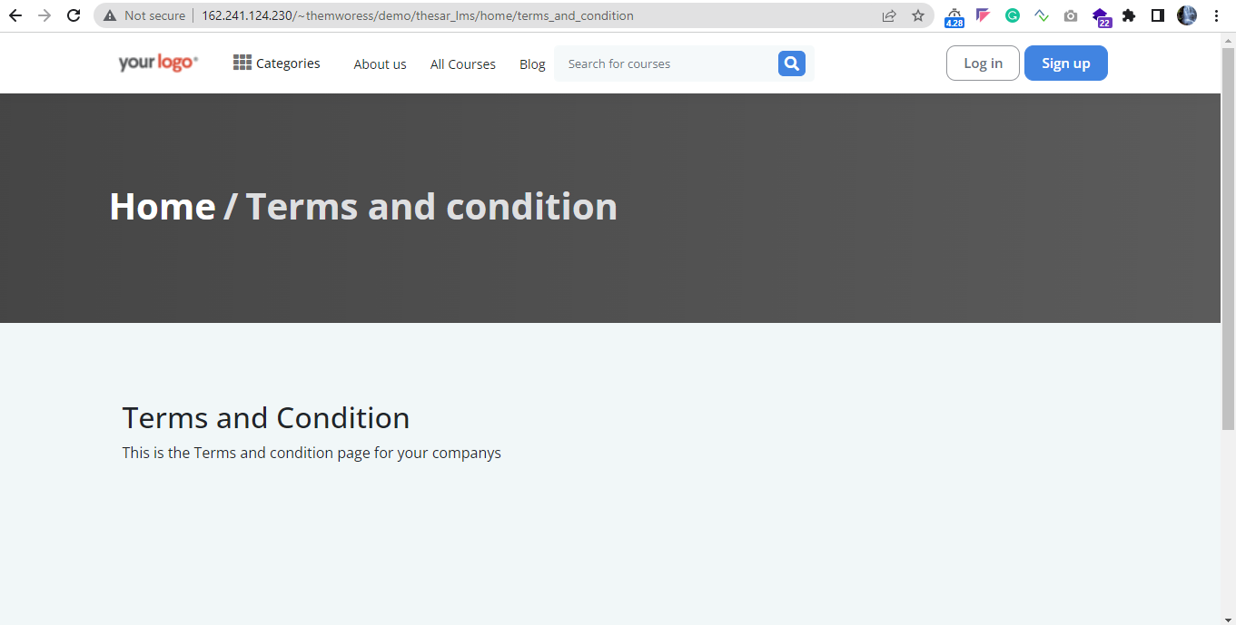

11. Refund Policy
11.1 User may learn about the learning management system by this footer menu link.
Status: Completed
URL: http://162.241.124.230/~themworess/demo/thesar_lms/home/refund_policy
Screenshot:
